## Visitor

### Search

* + - Navigate to homepage
    - Select type of house, province, and district where you want to search
    - Enter additional keyword
    - Click search, or hit Enter

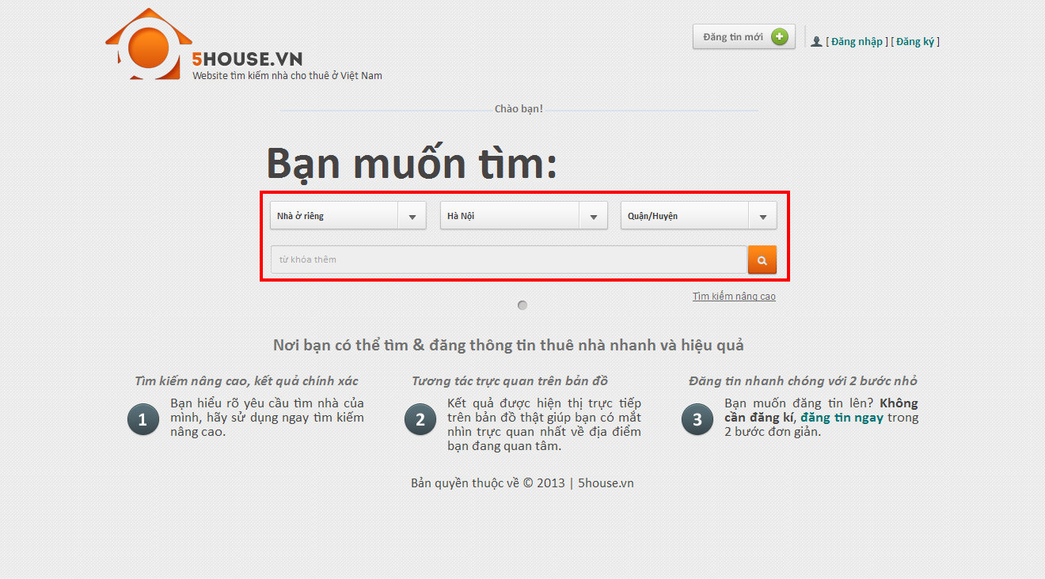

## Advanced Search

* + - Navigate to homepage
    - Click “Tìm kiếm nâng cao”
    - Select type of house, province, and district where you want to search
    - Provide desired price range and area range (not required)
    - Provide information concerning facilities priorities. There are 3 values of priority: Thấp, Vừa, Cao. Unpicked facilities will be ignored.

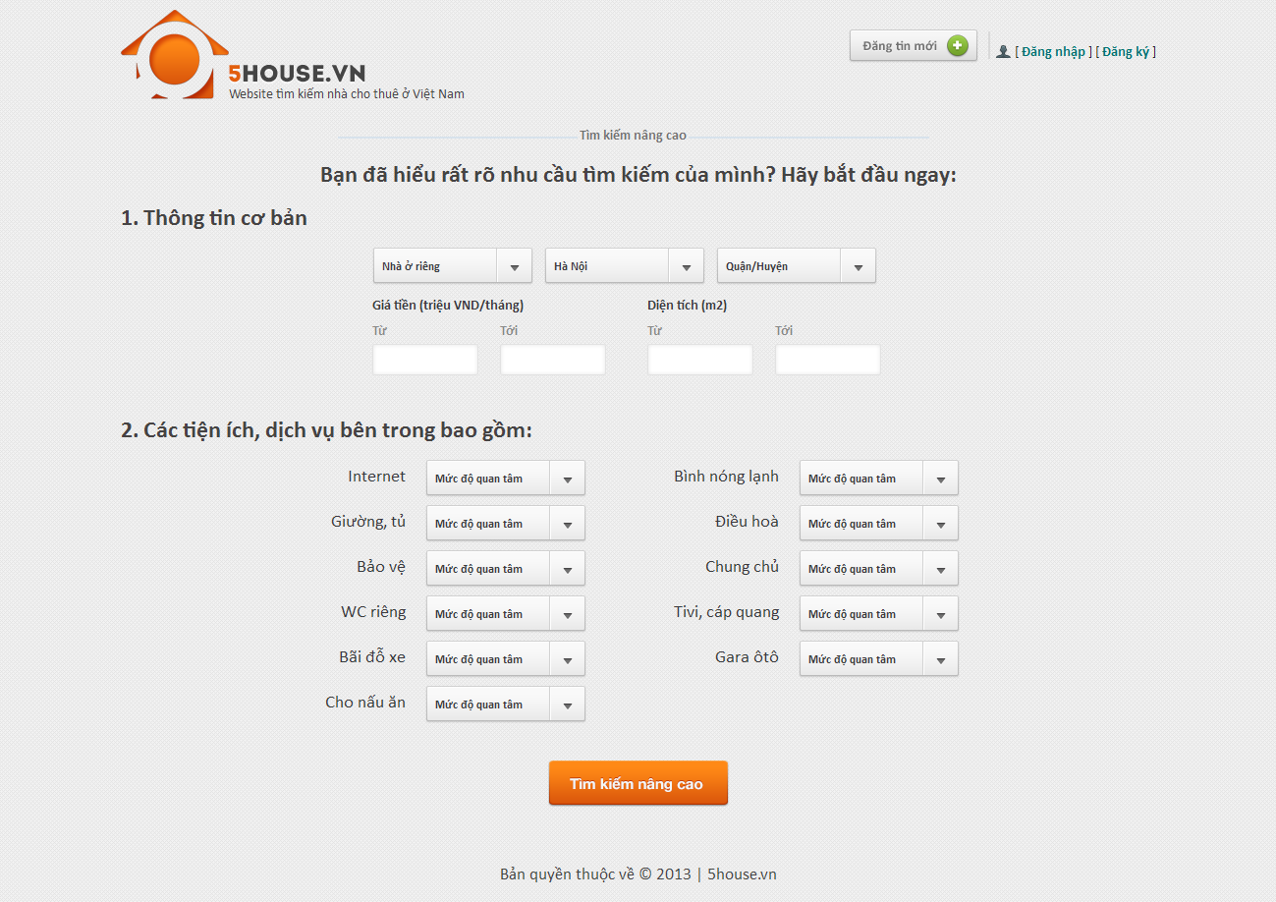

## View Post Detail

* + - Perform a search then click on a result on the list or a marker on the map, or enter the link directly to browser’s address bar

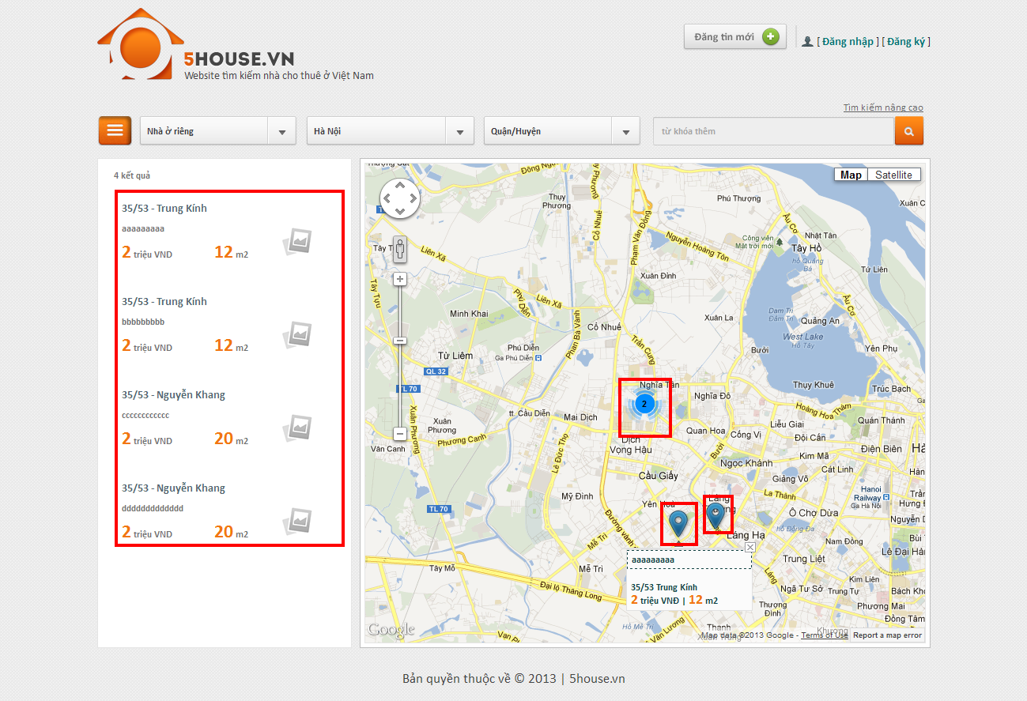

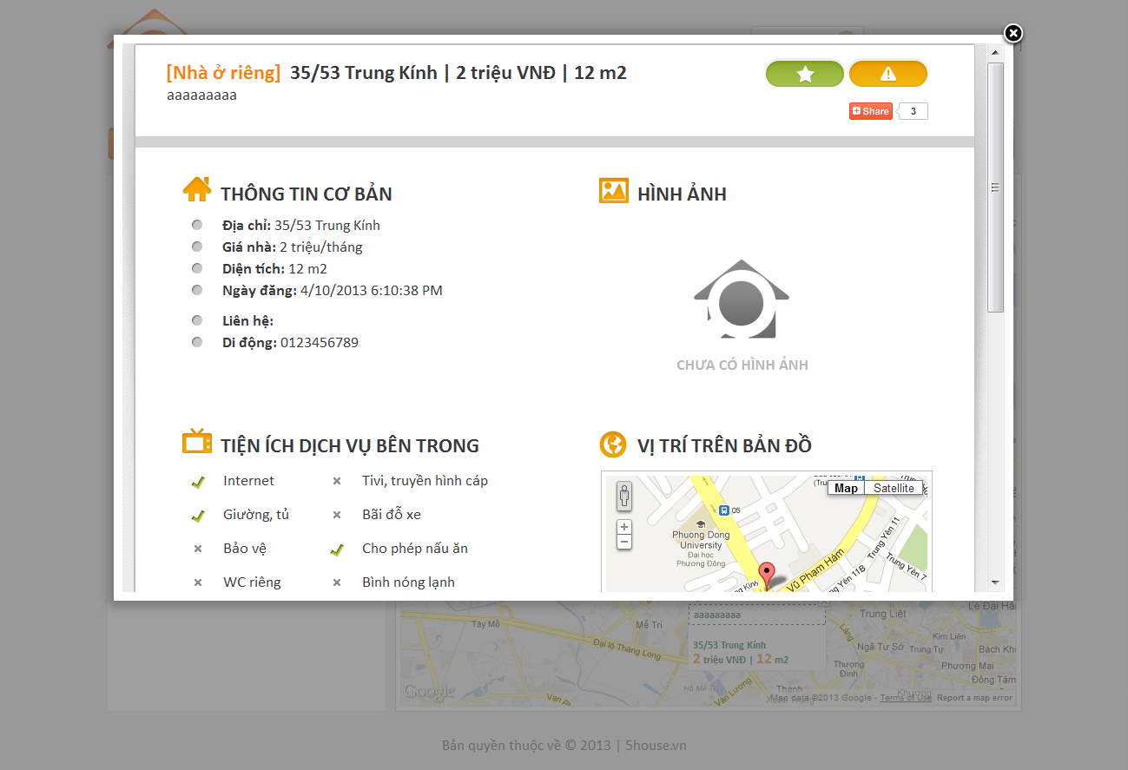

## Add Post

* + - Click on “Đăng tin mới” button on top of any page
    - Enter input as prompted

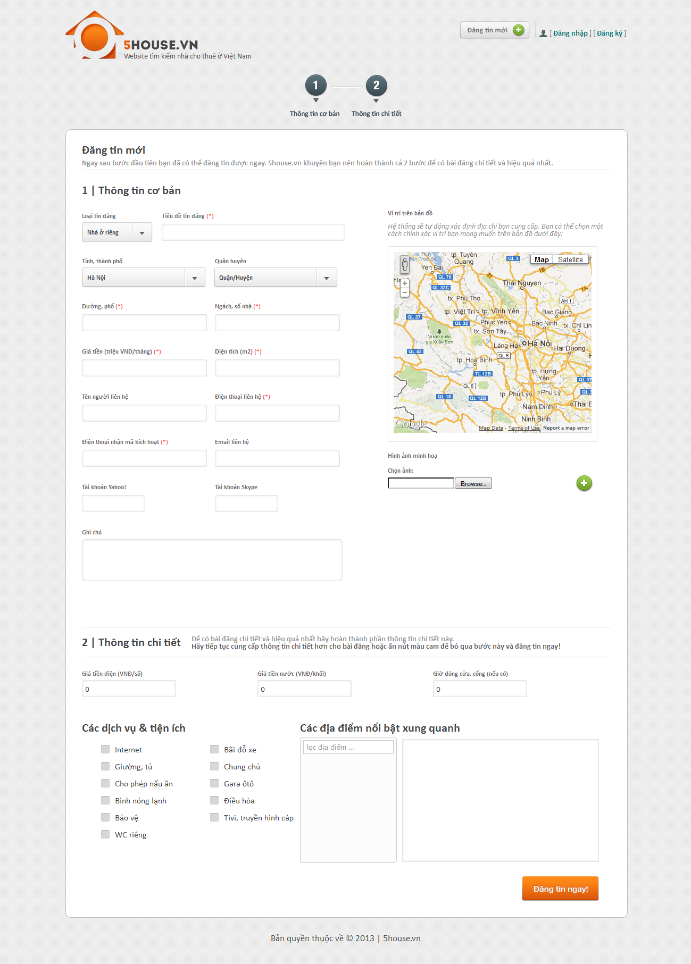

## Edit Post

* + - Enter the link provided when posting into the browser
    - Enter the provided password
    - Edit post details
    - Click “Lưu thay đổi” button

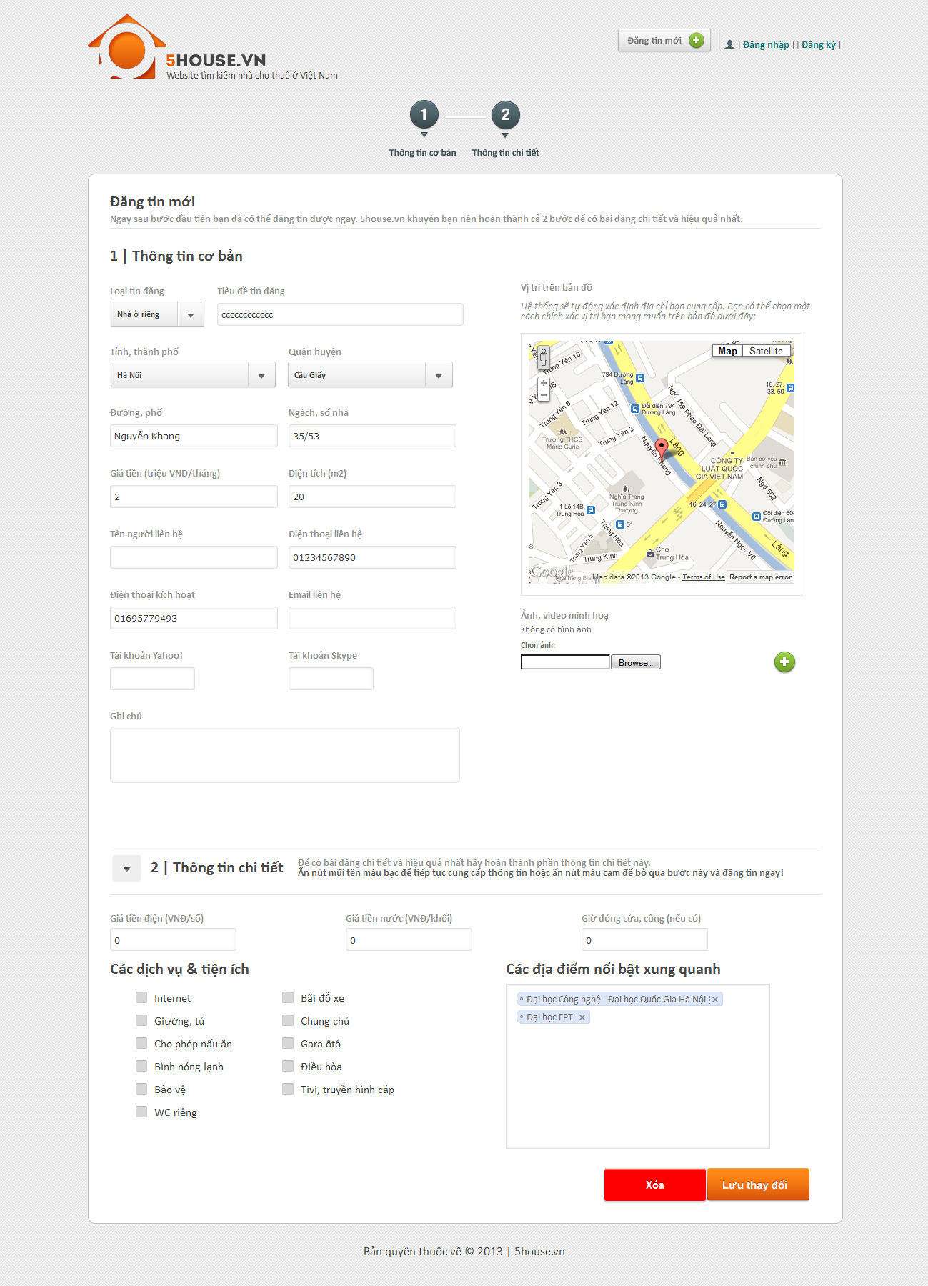

## Delete Post

* + - Enter the link provided when posting into the browser
    - Enter the provided password
    - Edit post details
    - Click “Xóa” button



## Renew Post

* + - Send and SMS with the following content to our SMS service
      * MS [password]

With [password] is the one that was provided when posting.

## Register

* + - Click on “Đăng ký” link
    - Provide details as prompted
    - Click “Đăng ký” button

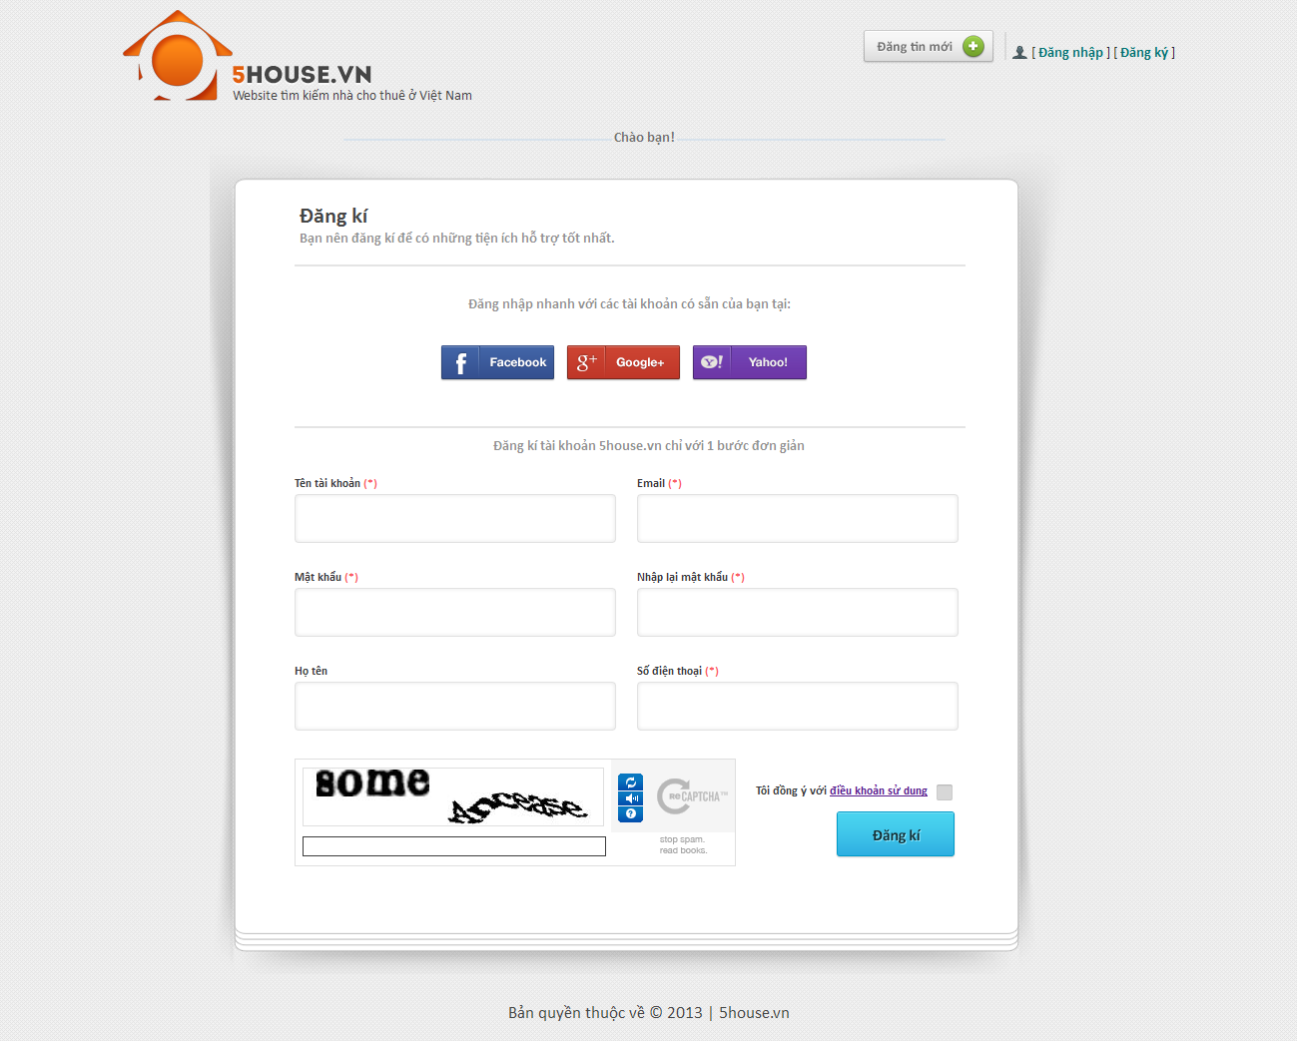

## User

## Login

* + - Click on “Đăng nhập” button
    - Login with registered username and password, or use Facebook/Google/Yahoo ID

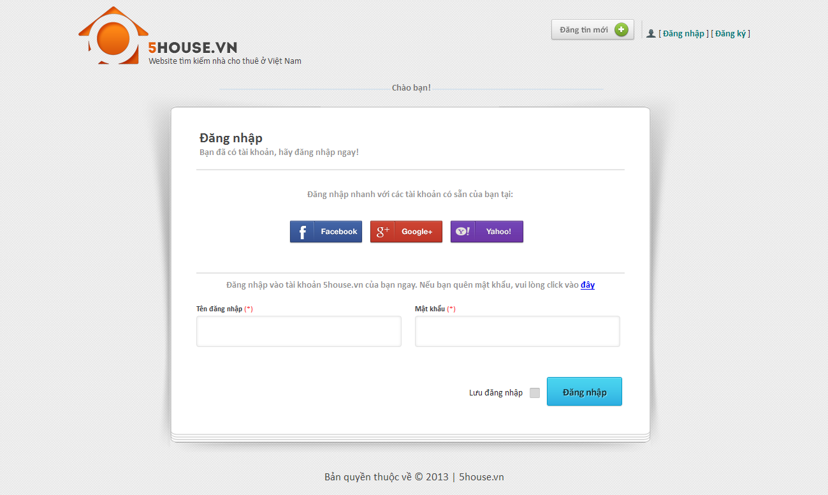

## Logout

* + - User must have logged into the system
    - Click on “Thoát” button

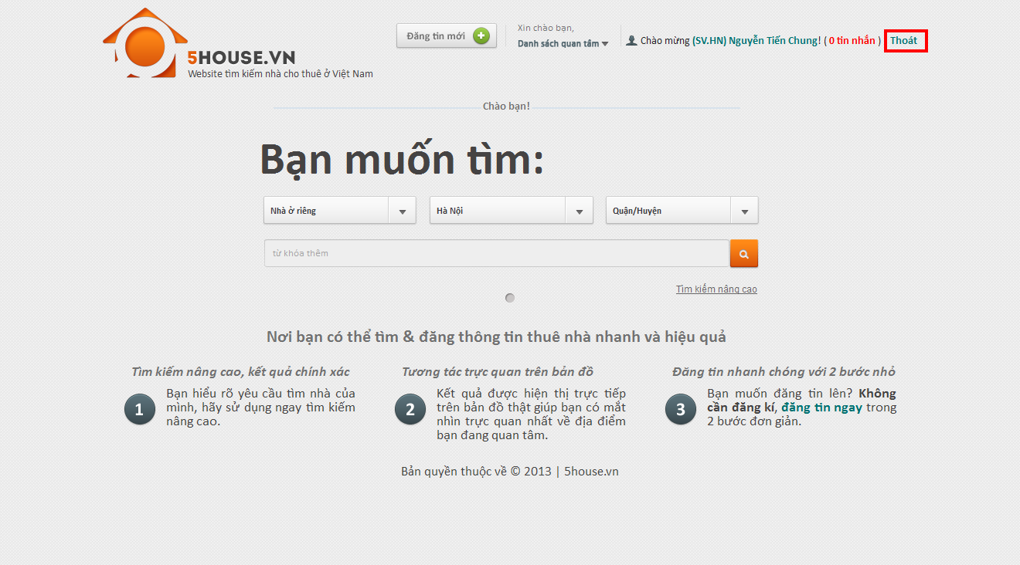

## Edit user profile

* + - Login to the system
    - Go to User Control Panel by clicking on the displayed username on top of the page
    - Click “Thay đổi thong tin” button
    - Edit user details
    - Click “Lưu thay đổi” button

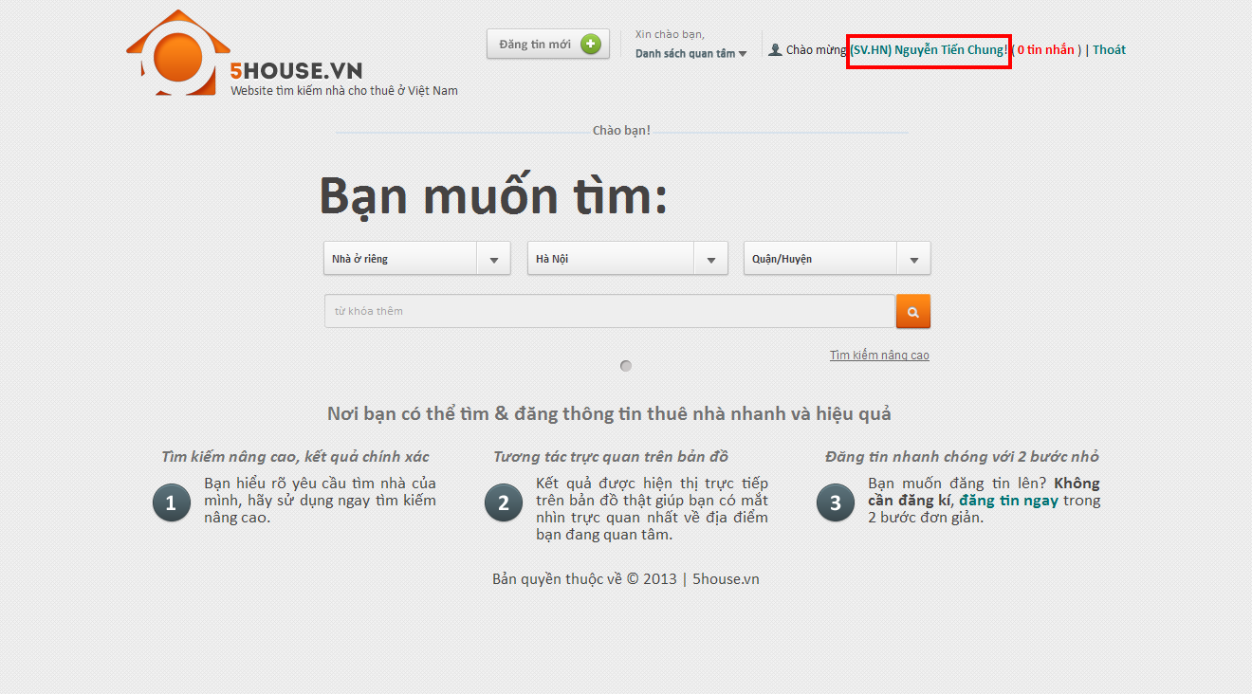

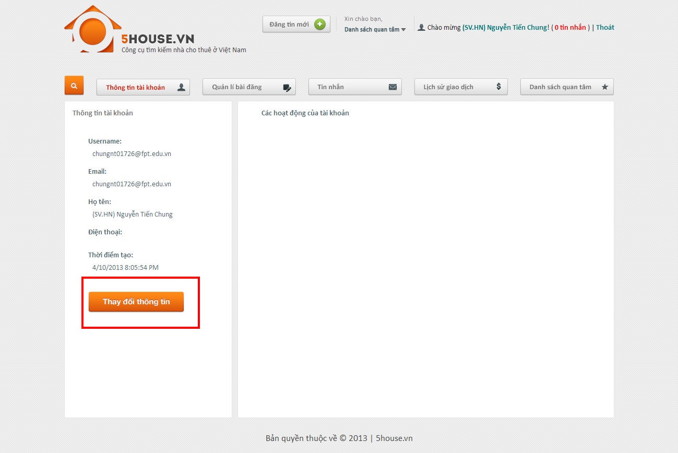

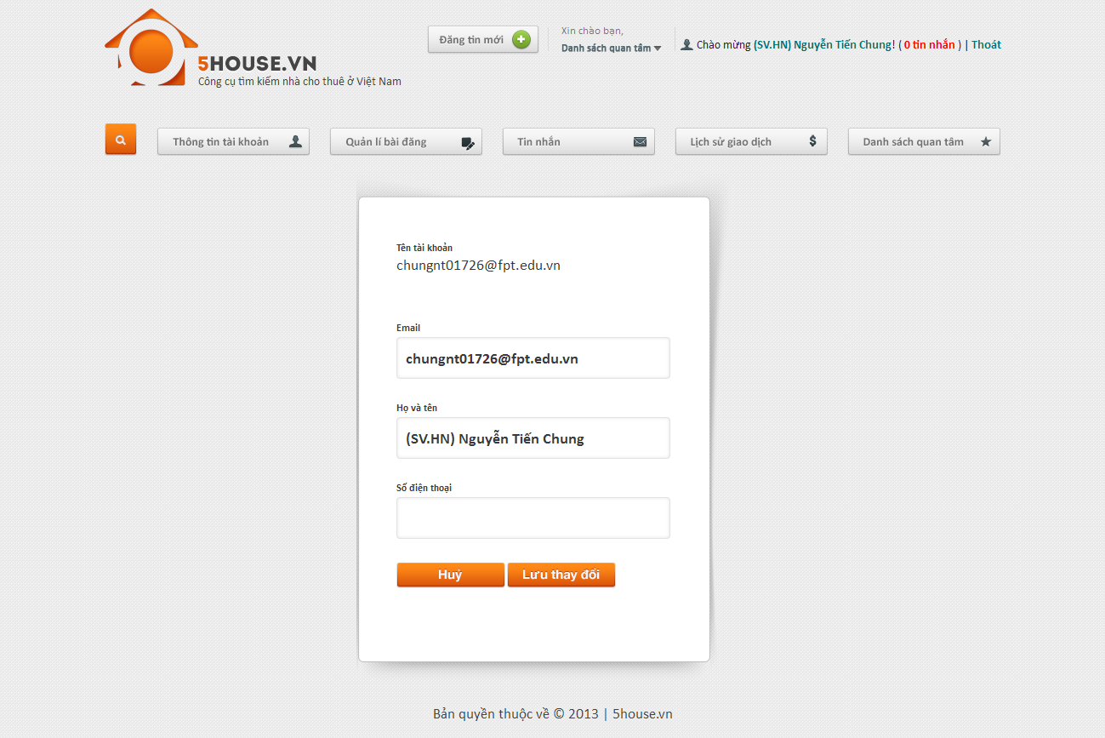

## Change password

* + - Login to the system
    - Go to User Control Panel
    - Click on “Đổi mật khẩu” button
    - Provide new password
    - Click “Lưu thay đổi”

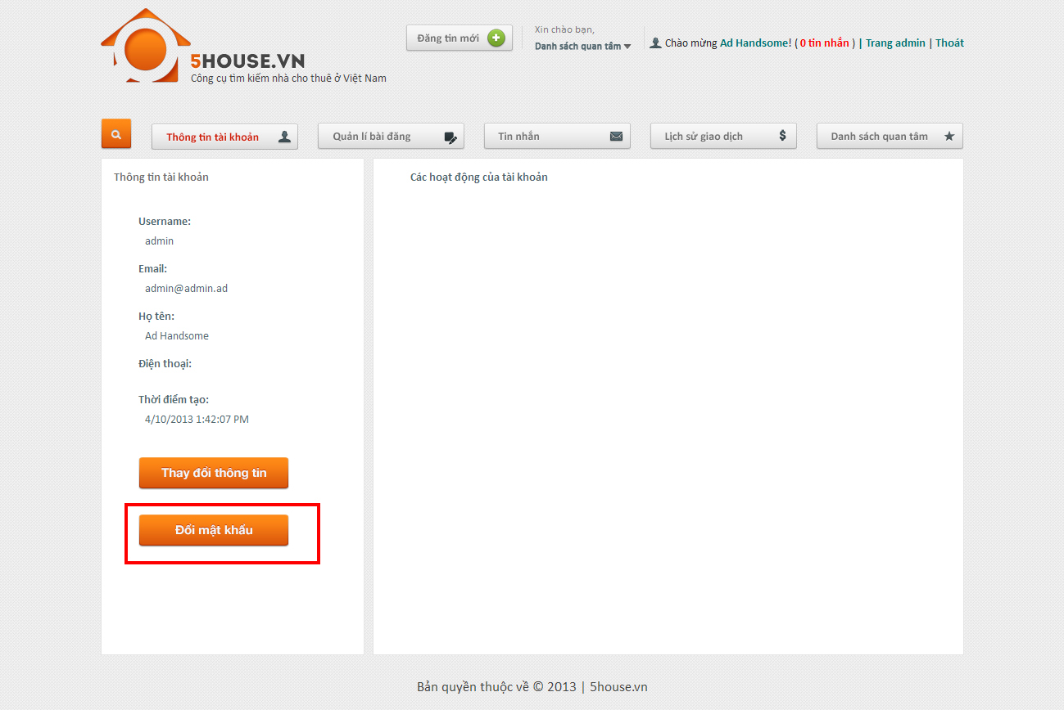

## Recover password

* + - Go to login page
    - Click on password recovery link
    - Click button

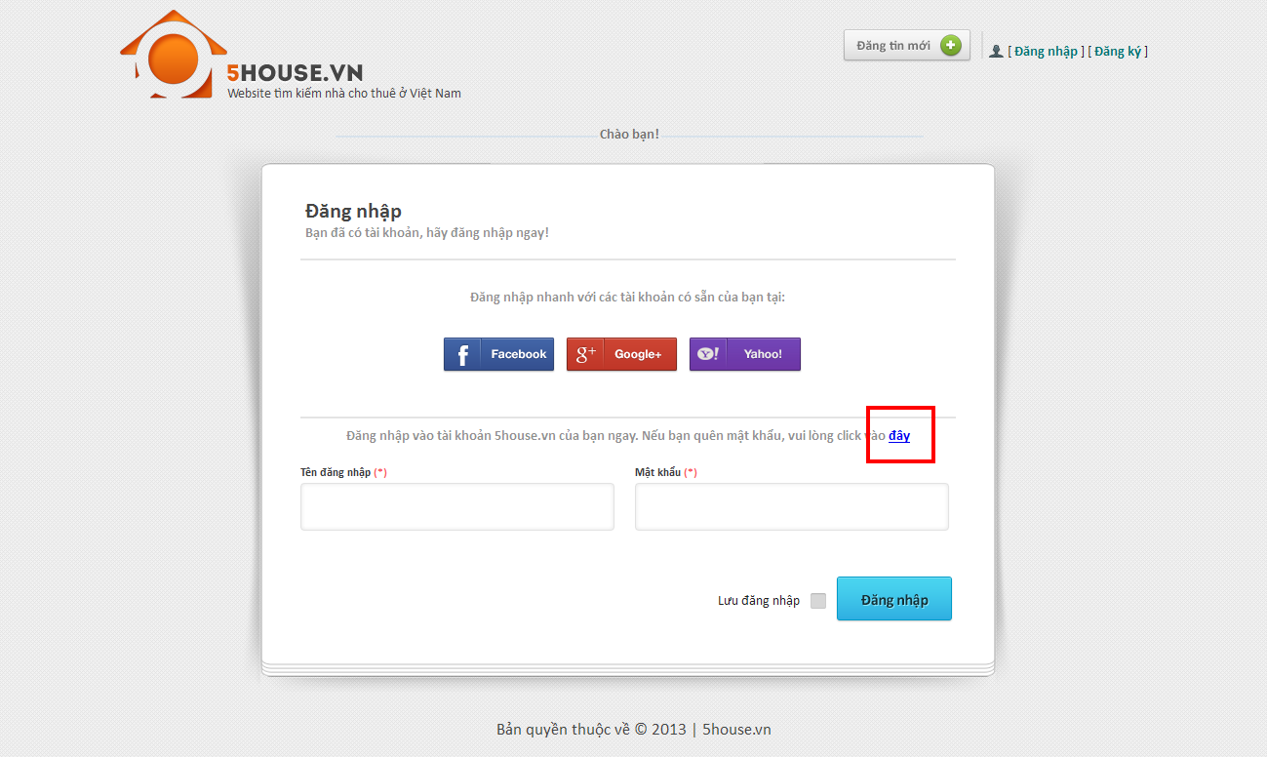

## View favorite list

* + - Go to User Control Panel
    - Click on “Quản lý bài đăng” button

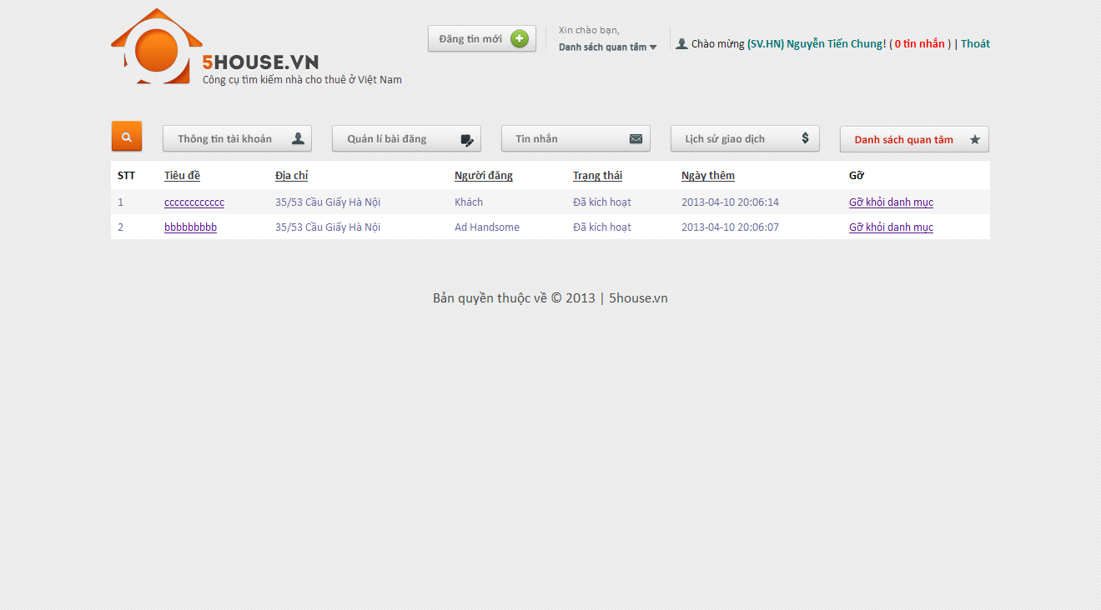

## Add favorite

* + - View a post which is not in favorite list
    - Click on Favorite button

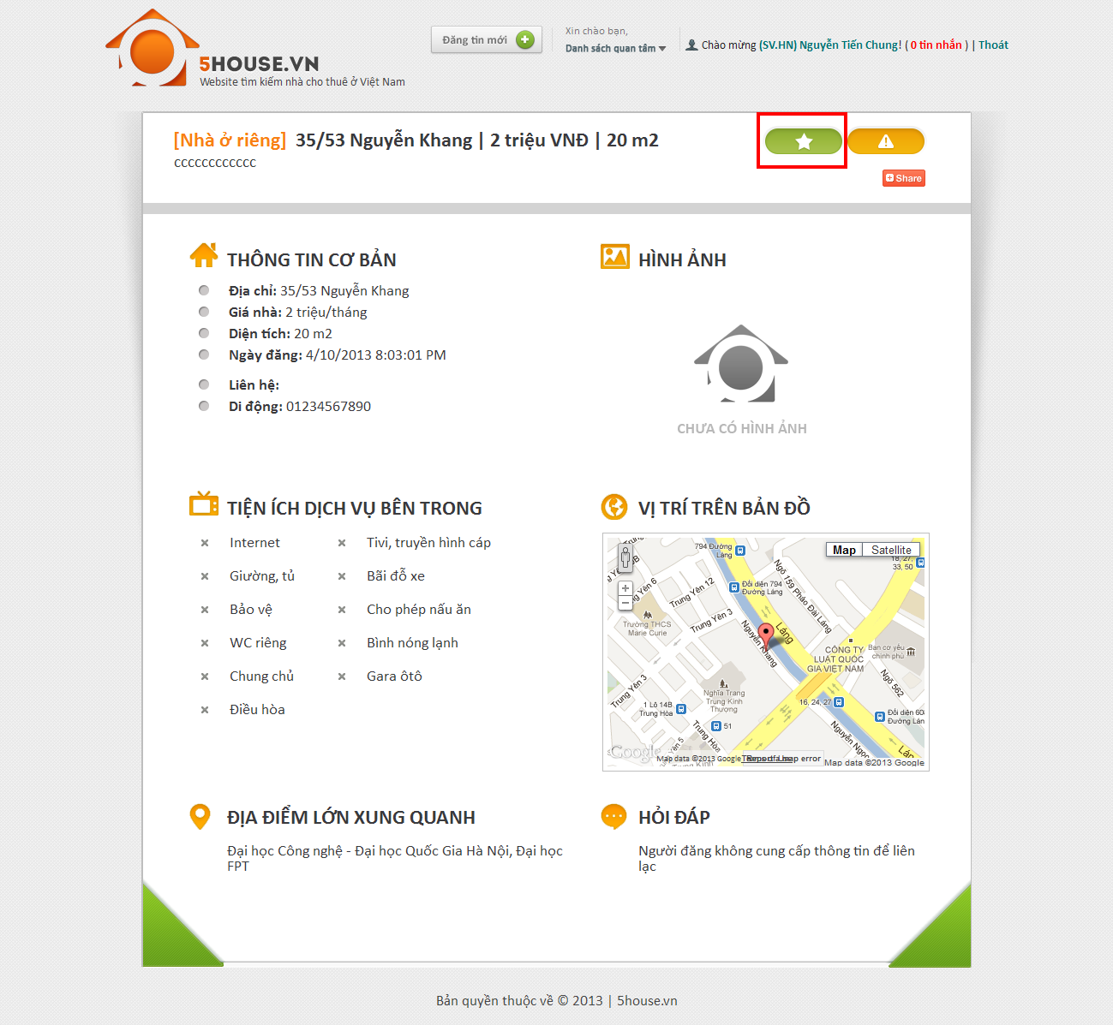

## Remove favorite

* + - View a post which is currently in favorite list
    - Click on Favorite button

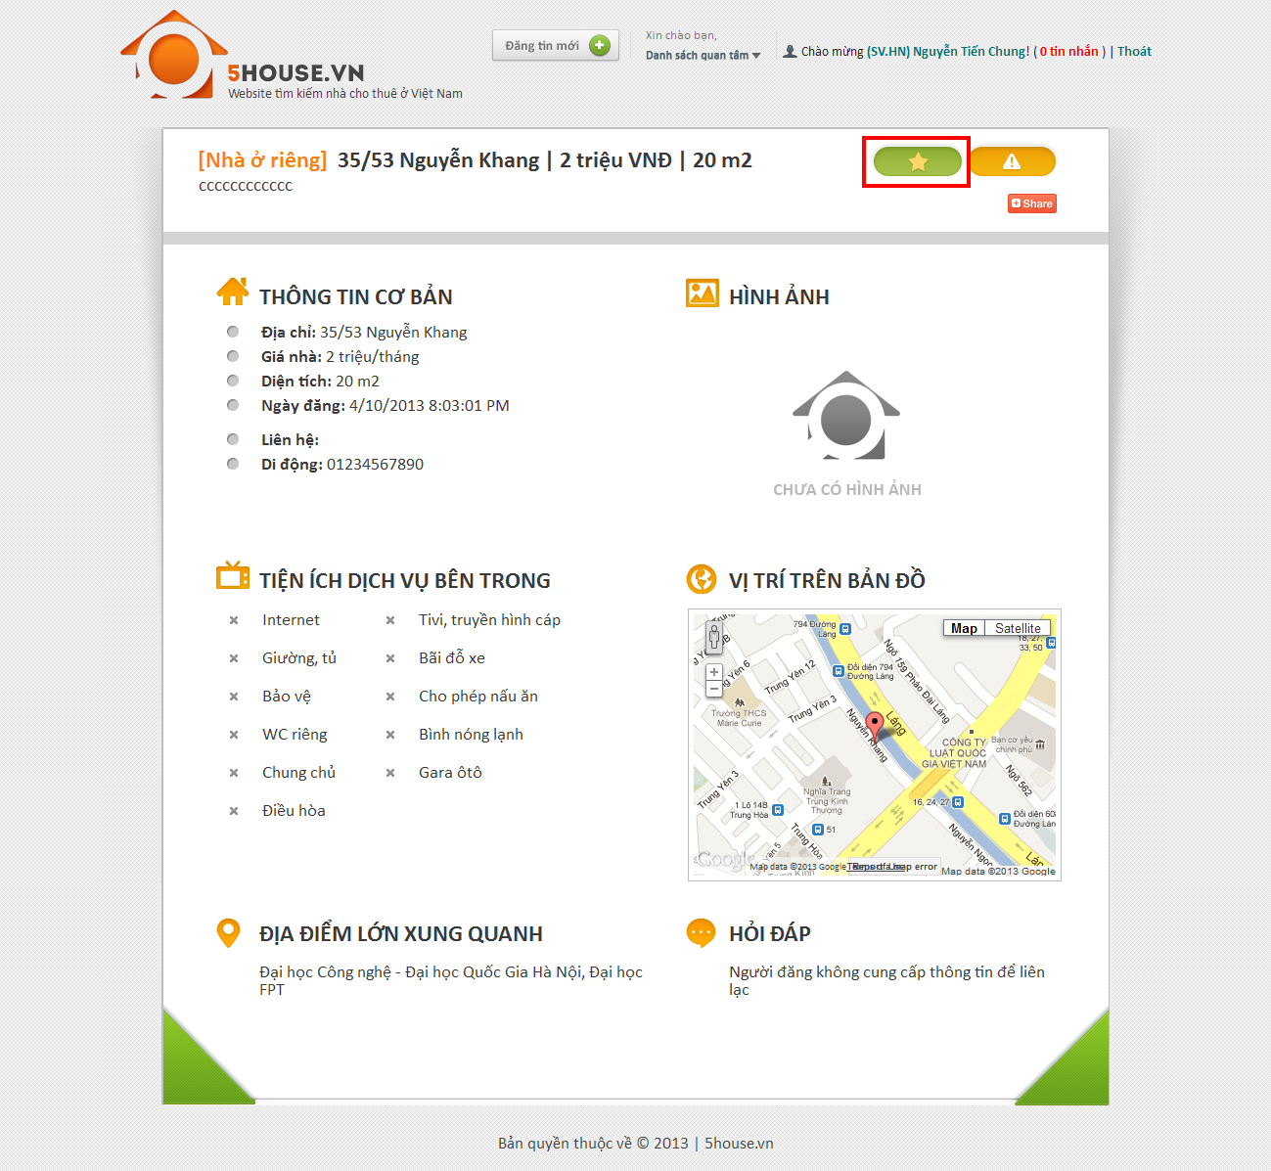

## Compare

* + - Add at least 2 post to favorite list
    - Click on “Danh sách quan tâm” link
    - Check at least 2 post
    - Click “So sánh”

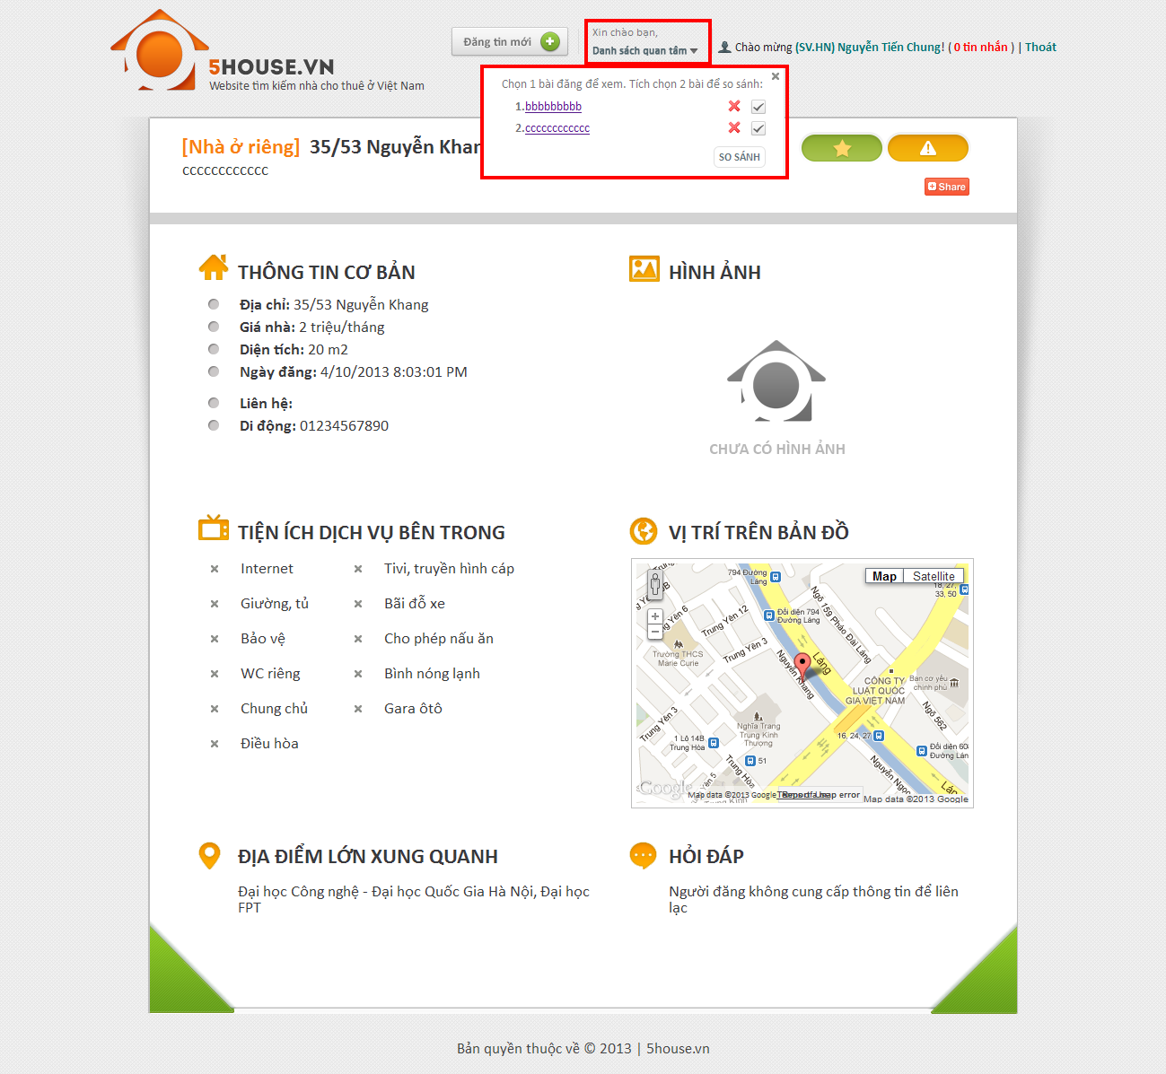

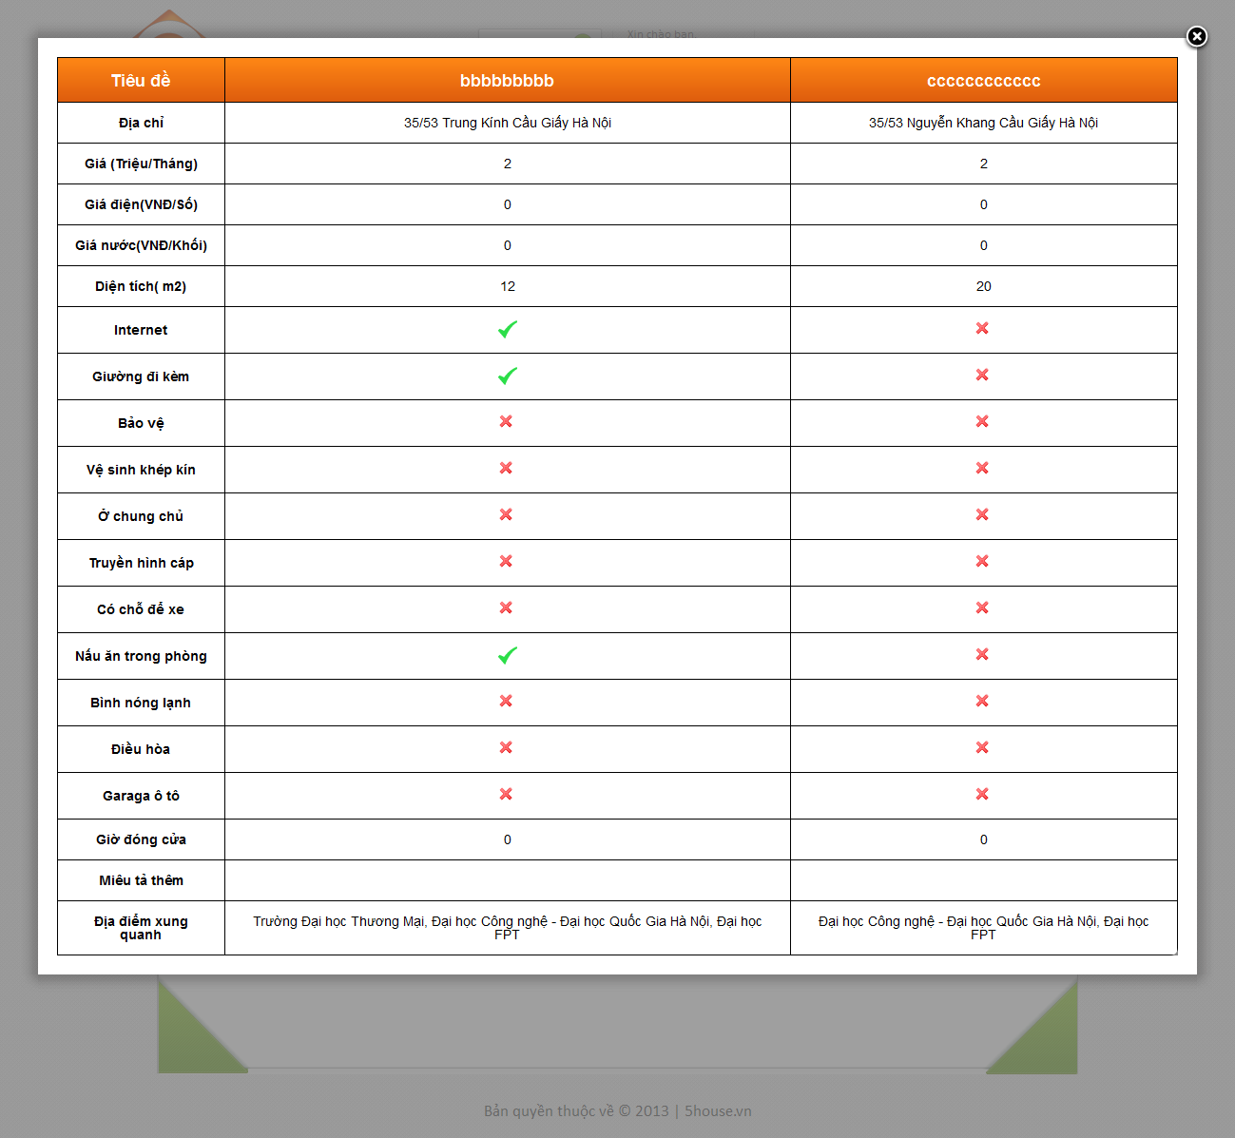

## Manage post

* + - Go to User Control Panel
    - Click on “Quản lý bài đăng” button

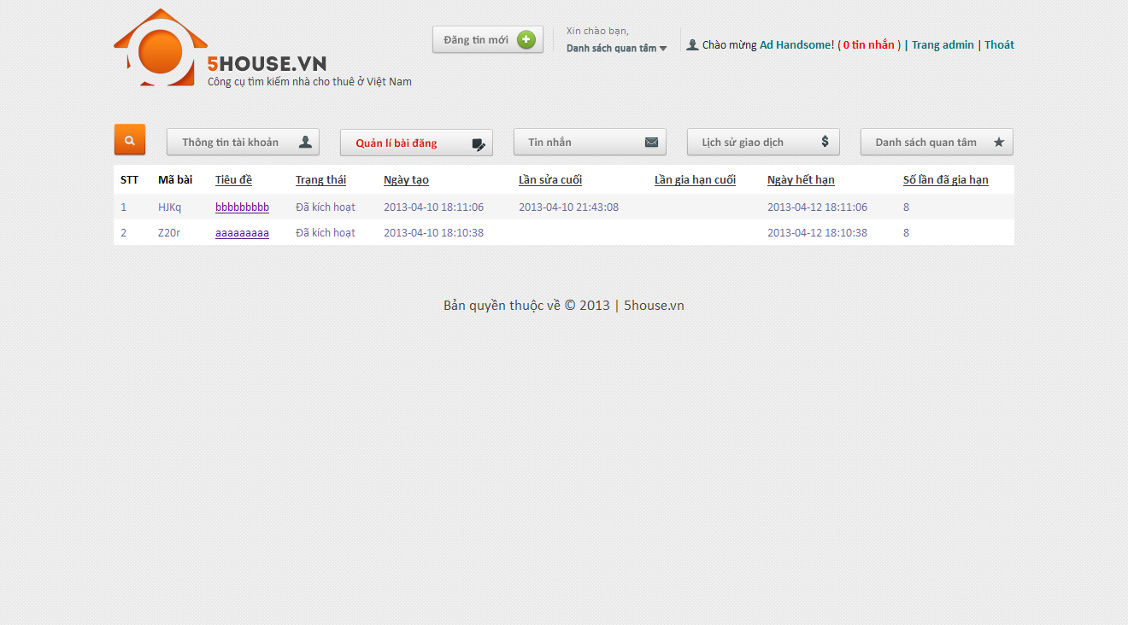

## Manage payment

* + - Go to User Control Panel
    - Click on “Lịch sử giao dịch” button

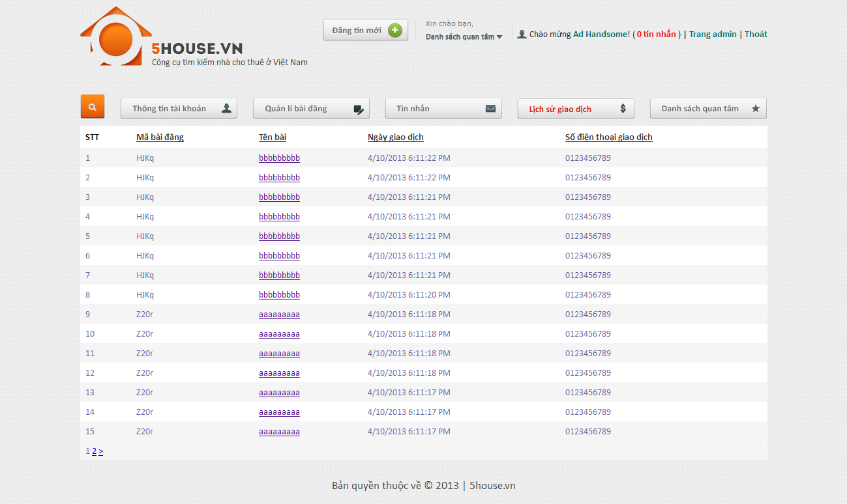

## Administrator

## Manage posts

* + - Login to the system as admin
    - Go to Admin Management page
    - Click on “Bài đăng” tab

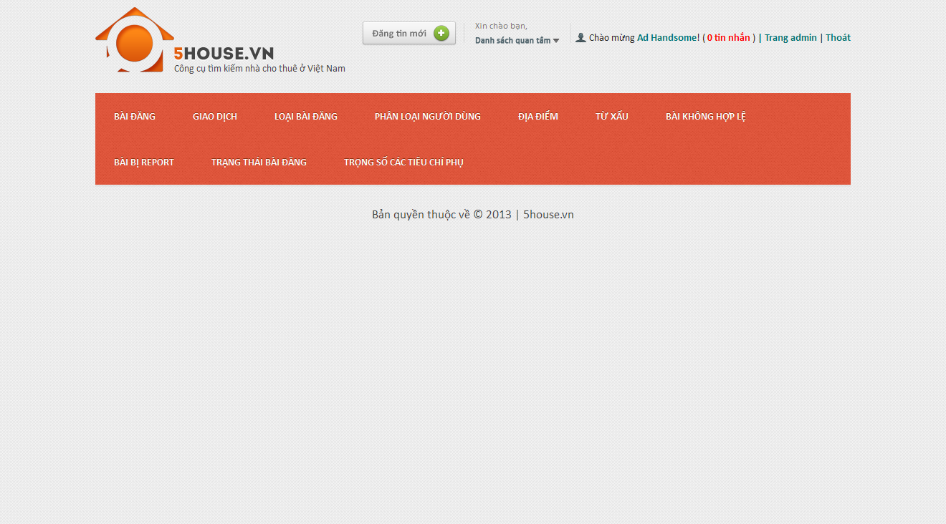

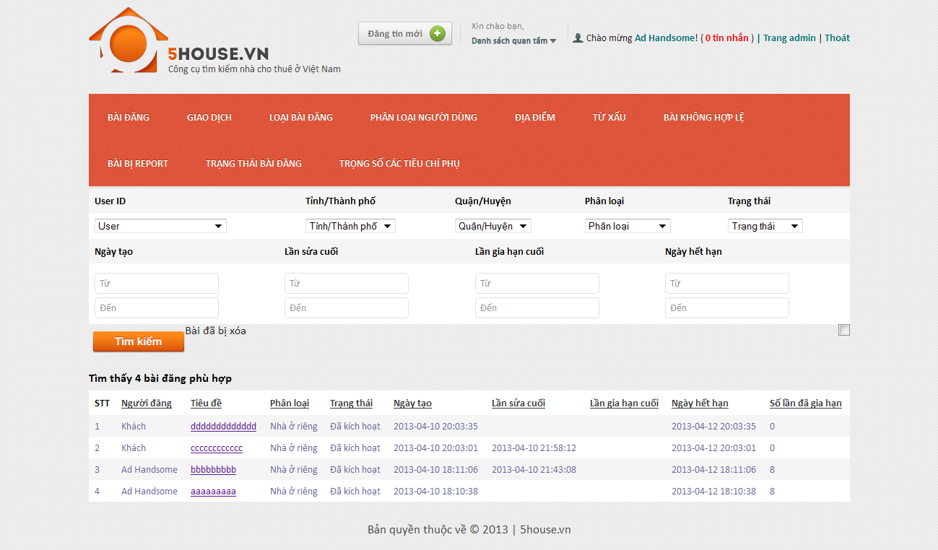

## Manage payments

* + - Login to the system as admin
    - Go to Admin Management page
    - Click on “Giao dịch” tab

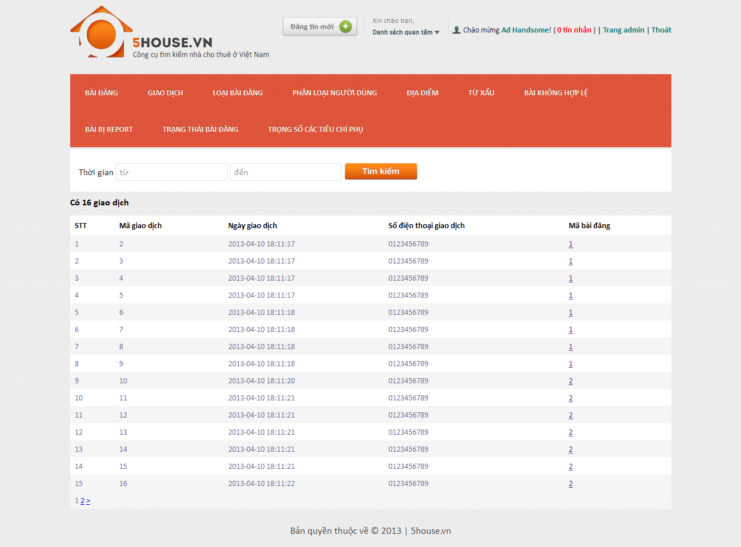

## Manage post categories

## View categories list

* + - * Login to the system as admin
      * Go to Admin Management page
      * Click on “Loại bài đăng” tab

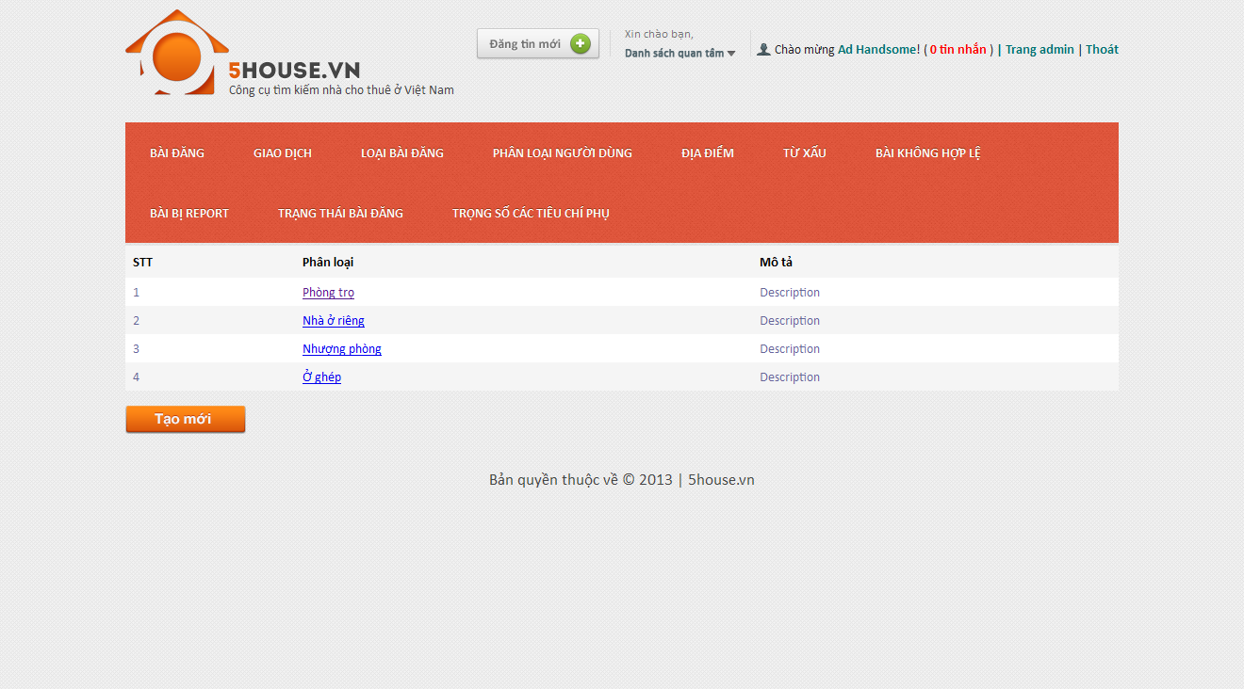

## Create new category

* + - * Login to the system as admin
      * Go to Admin Management page
      * Click on “Loại bài đăng” tab
      * Click on “Tạo mới” button
      * Enter details as prompted
      * Click on “Tạo mới” button

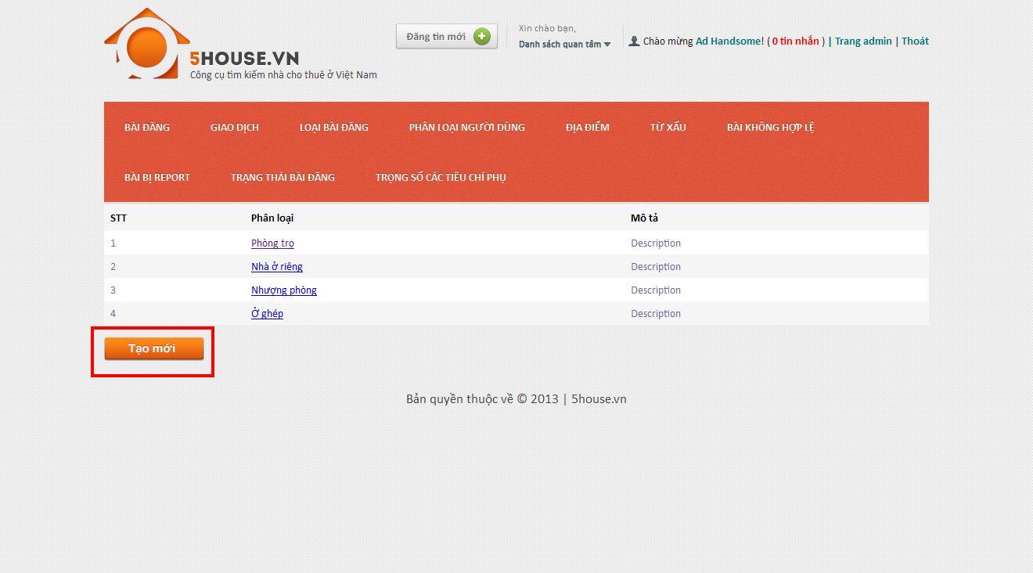

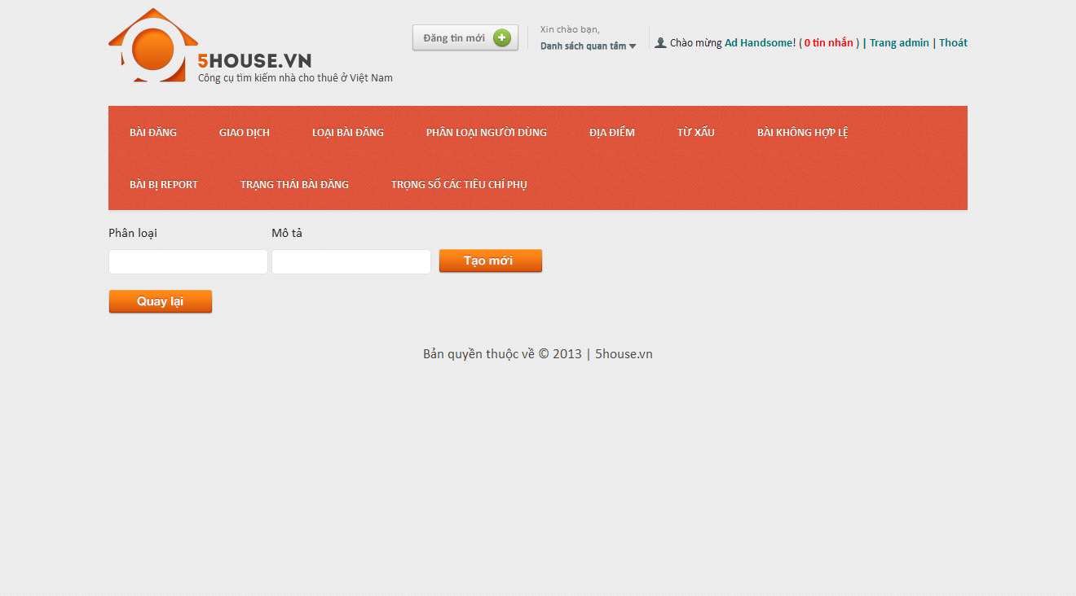

## Edit category

* + - * Login to the system as admin
      * Go to Admin Management page
      * Click on “Loại bài đăng” tab
      * Click on an item on the table
      * Modify details
      * Click on “Lưu thay đổi” button

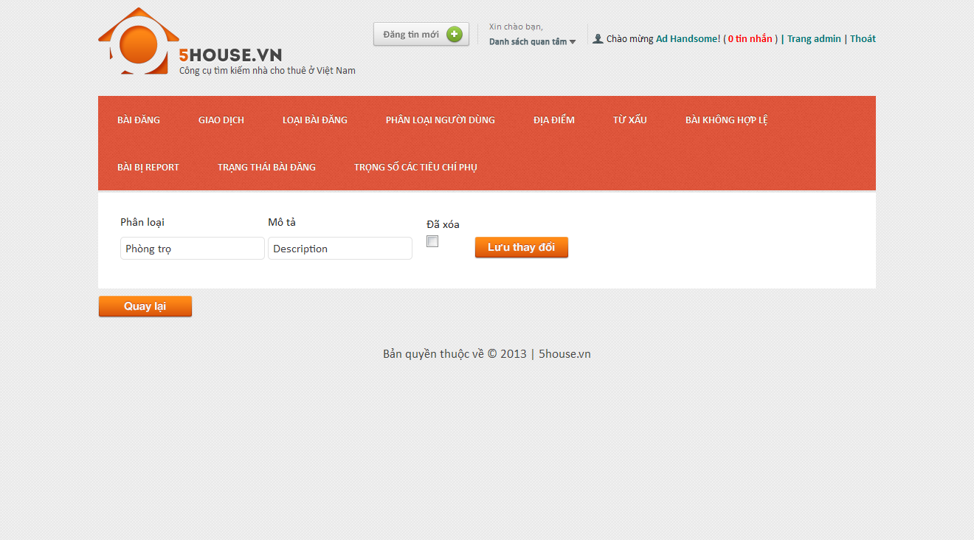

## Manage user roles

## View roles list

* + - * Login to the system as admin
      * Go to Admin Management page
      * Click on “Phân loại người dùng” tab

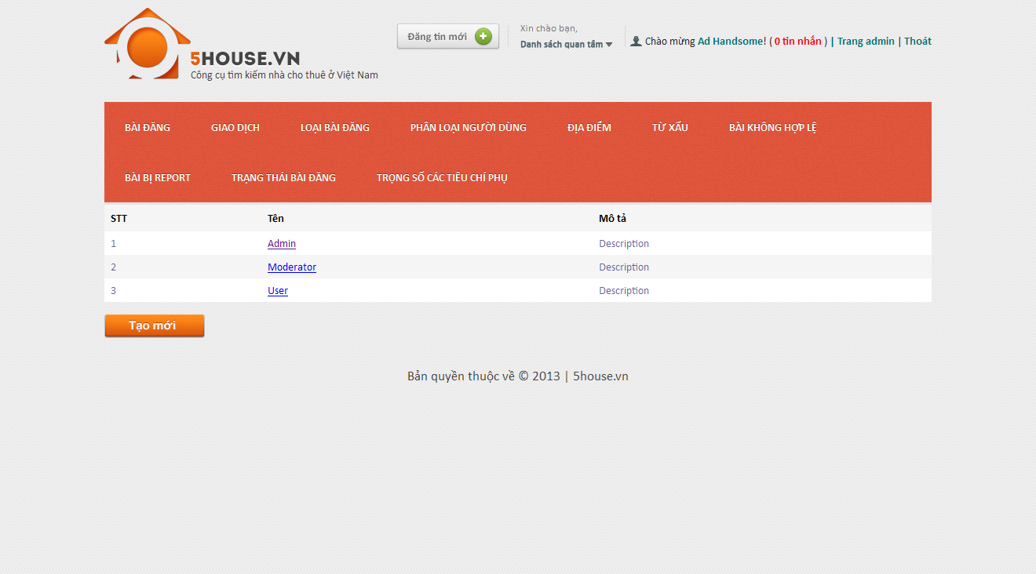

## Create new role

* + - * Login to the system as admin
      * Go to Admin Management page
      * Click on “Phân loại người dùng” tab
      * Click “Tạo mới” button

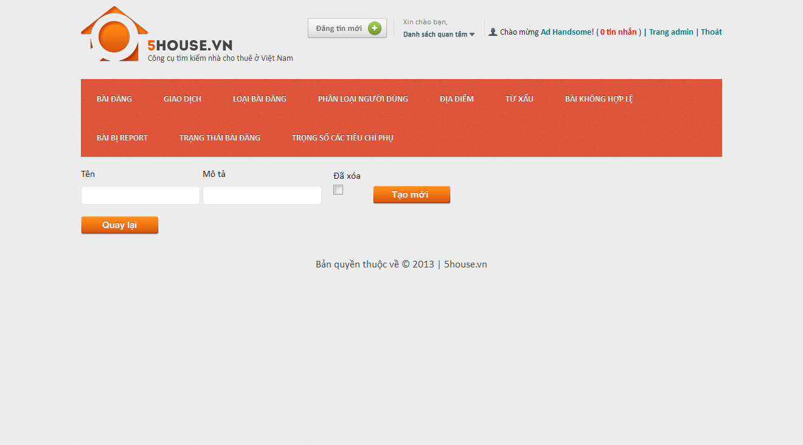

## Edit role

* + - * Login to the system as admin
      * Go to Admin Management page
      * Click on “Phân loại người dùng” tab
      * Click on an item on the table
      * Modify details
      * Click on “Lưu thay đổi” button

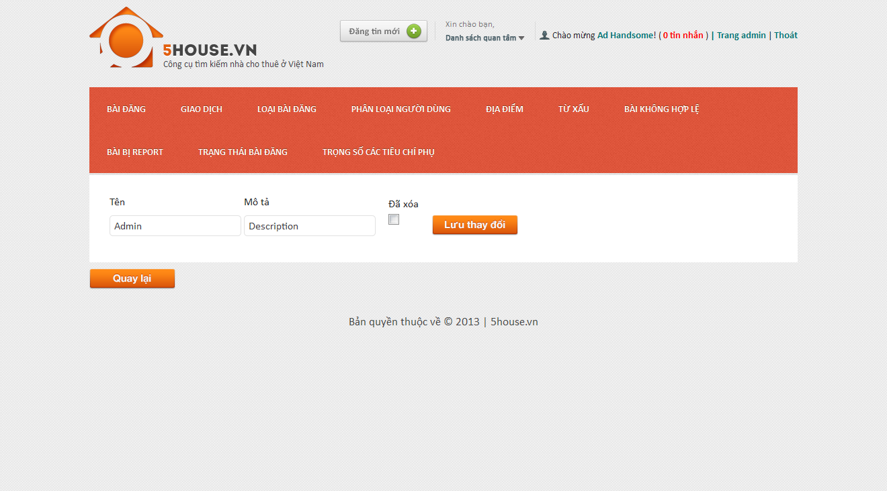

## Manage provinces

## View provinces list

* + - * Login to the system as admin
      * Go to Admin Management page
      * Point on “Địa điểm”
      * Click on “Tỉnh/Thành” tab

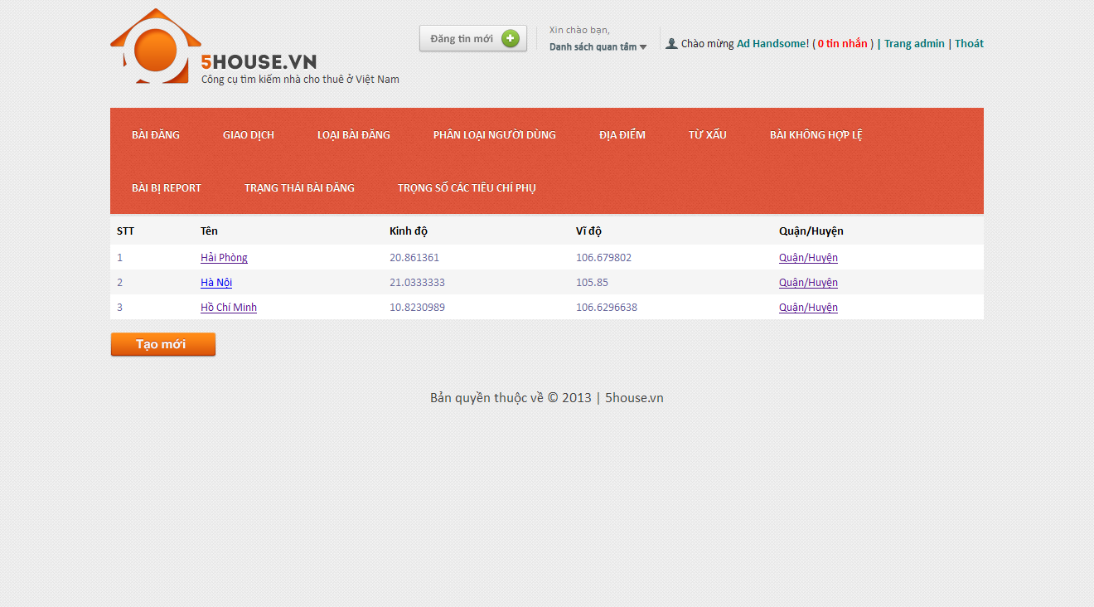

## Add new province

* + - * Login to the system as admin
      * Go to Admin Management page
      * Point on “Địa điểm”
      * Click on “Tỉnh/Thành” tab
      * Click “Tạo mới” button

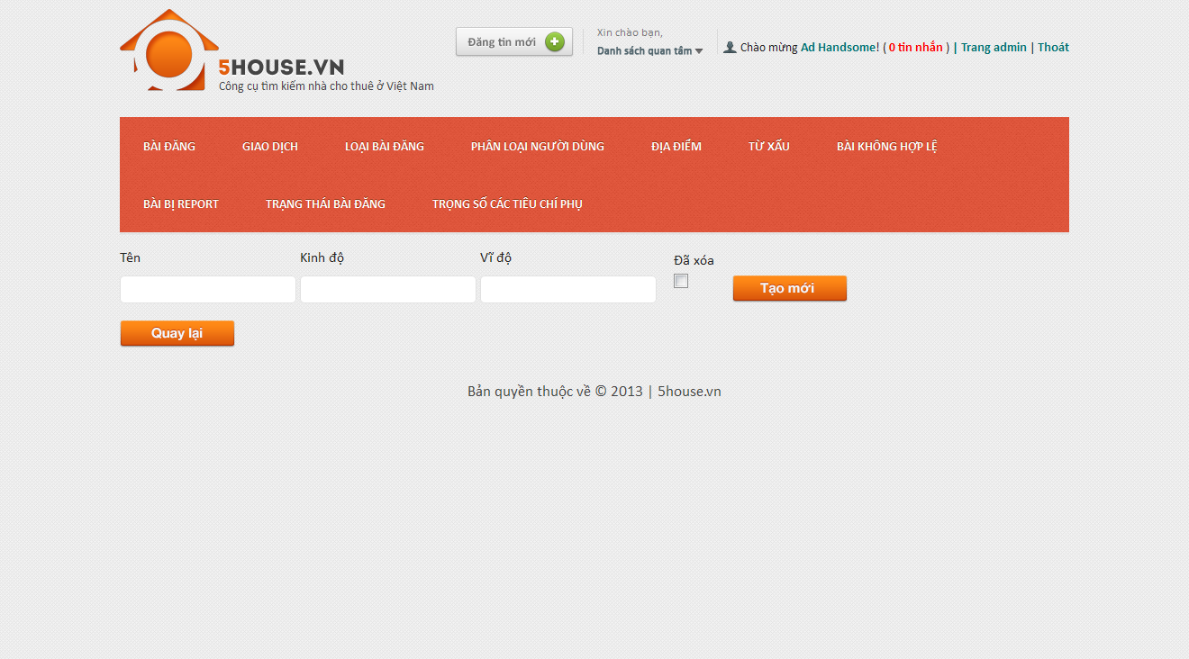

## Edit province

* + - * Login to the system as admin
      * Go to Admin Management page
      * Point on “Địa điểm”
      * Click on “Tỉnh/Thành” tab
      * Click on an item on the table
      * Modify details
      * Click on “Lưu thay đổi” button

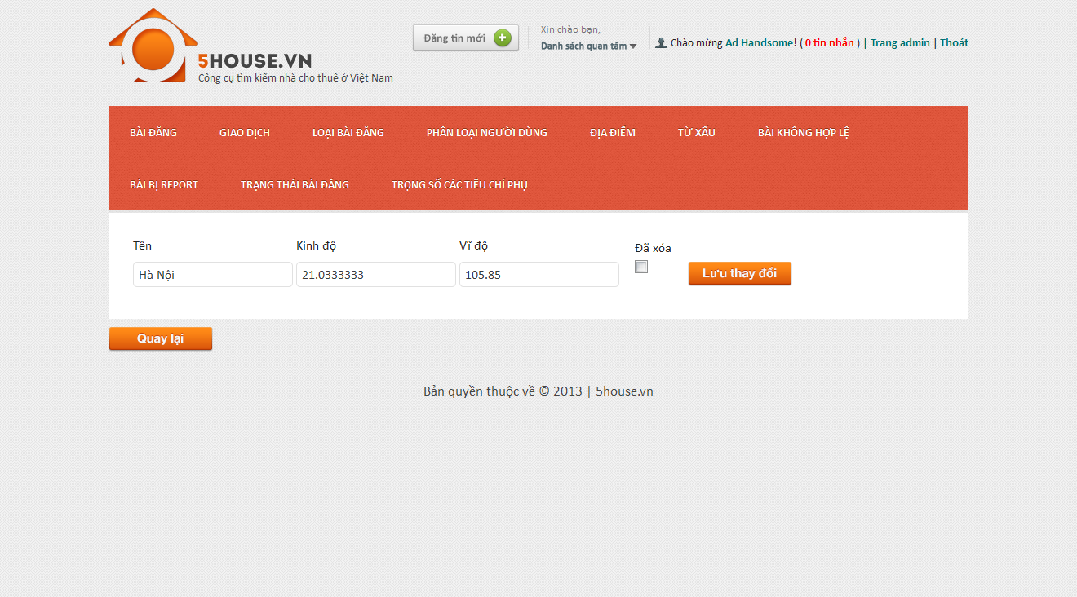

## Manage districts

## View districts list

* + - * Login to the system as admin
      * Go to Admin Management page
      * Point on “Địa điểm”
      * Click on “Quận/Huyện” tab

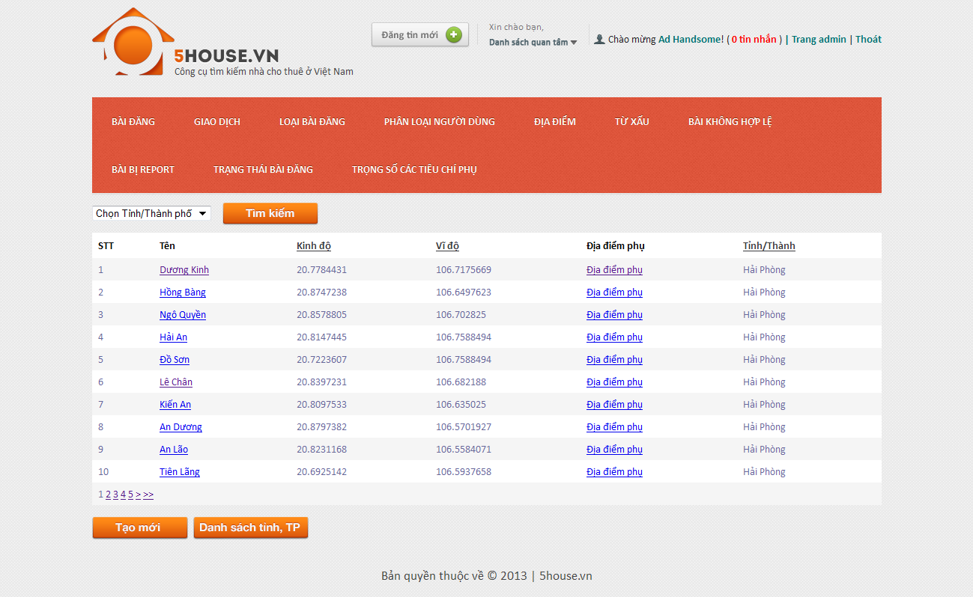

## Add new district

* + - * Login to the system as admin
      * Go to Admin Management page
      * Point on “Địa điểm”
      * Click on “Quận/Huyện” tab
      * Click “Tạo mới” button

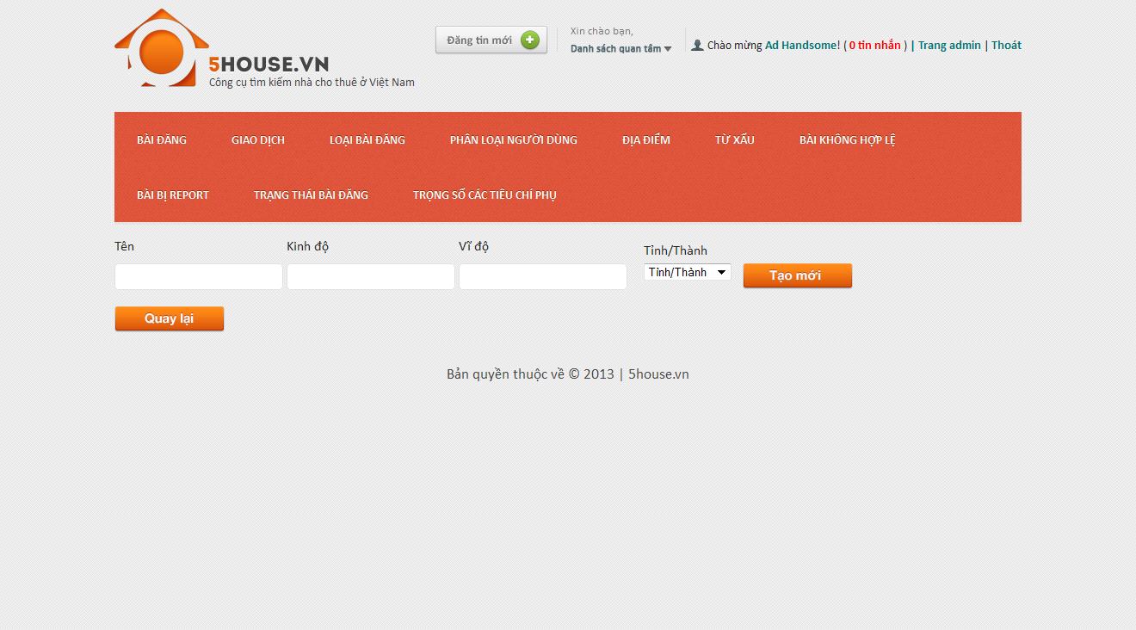

## Edit district

* + - * Login to the system as admin
      * Go to Admin Management page
      * Point on “Địa điểm”
      * Click on “Quận/Huyện” tab
      * Click on an item on the table
      * Modify details
      * Click on “Lưu thay đổi” button

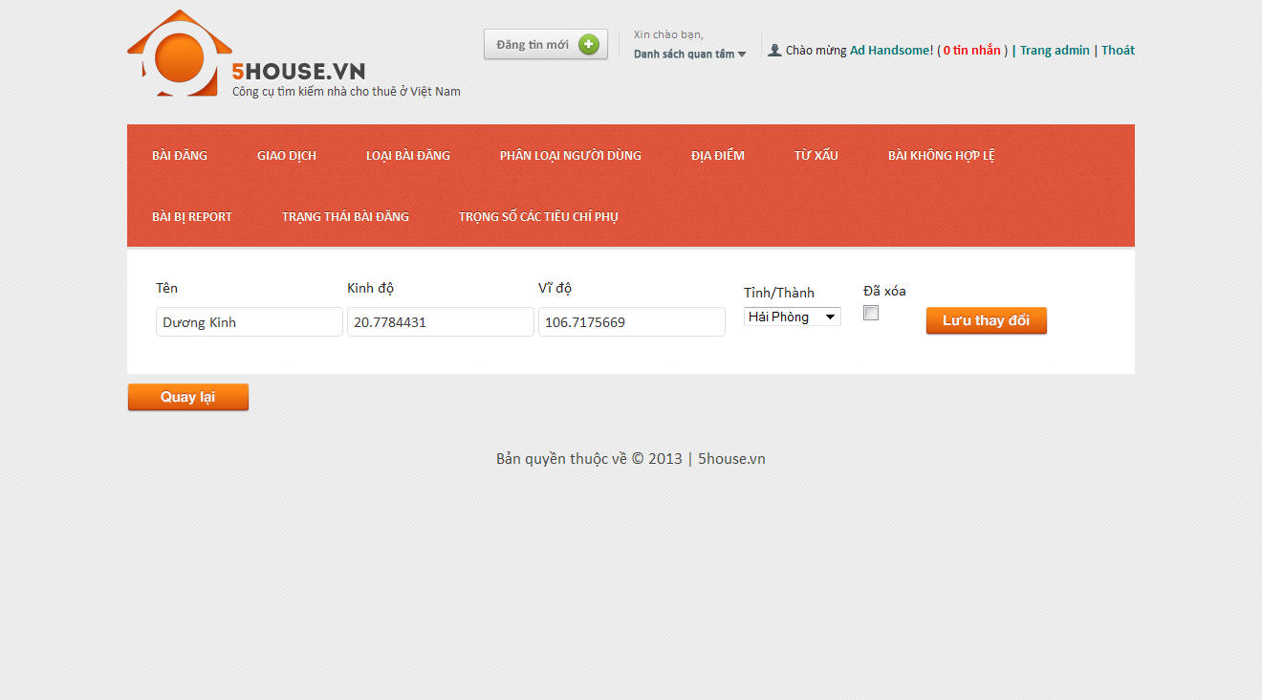

## Manage locations

## View locations list

* + - * Login to the system as admin
      * Go to Admin Management page
      * Point on “Địa điểm”
      * Click on “Địa điểm phụ” tab

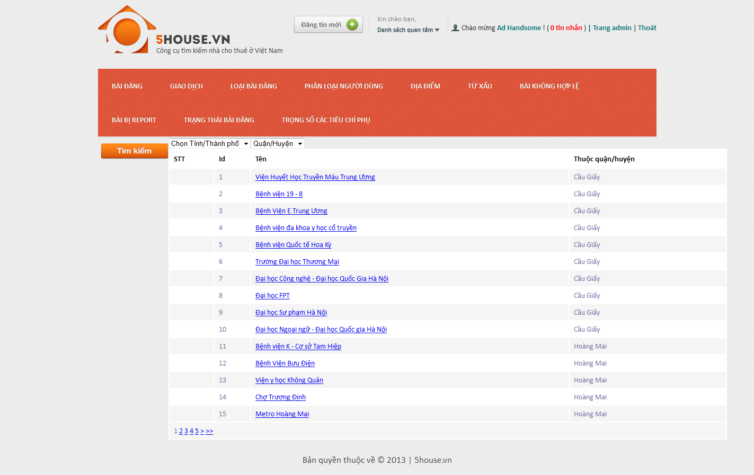

## Add new location

* + - * Login to the system as admin
      * Go to Admin Management page
      * Point on “Địa điểm”
      * Click on “Địa điểm phụ” tab
      * Click “Thêm mới” button

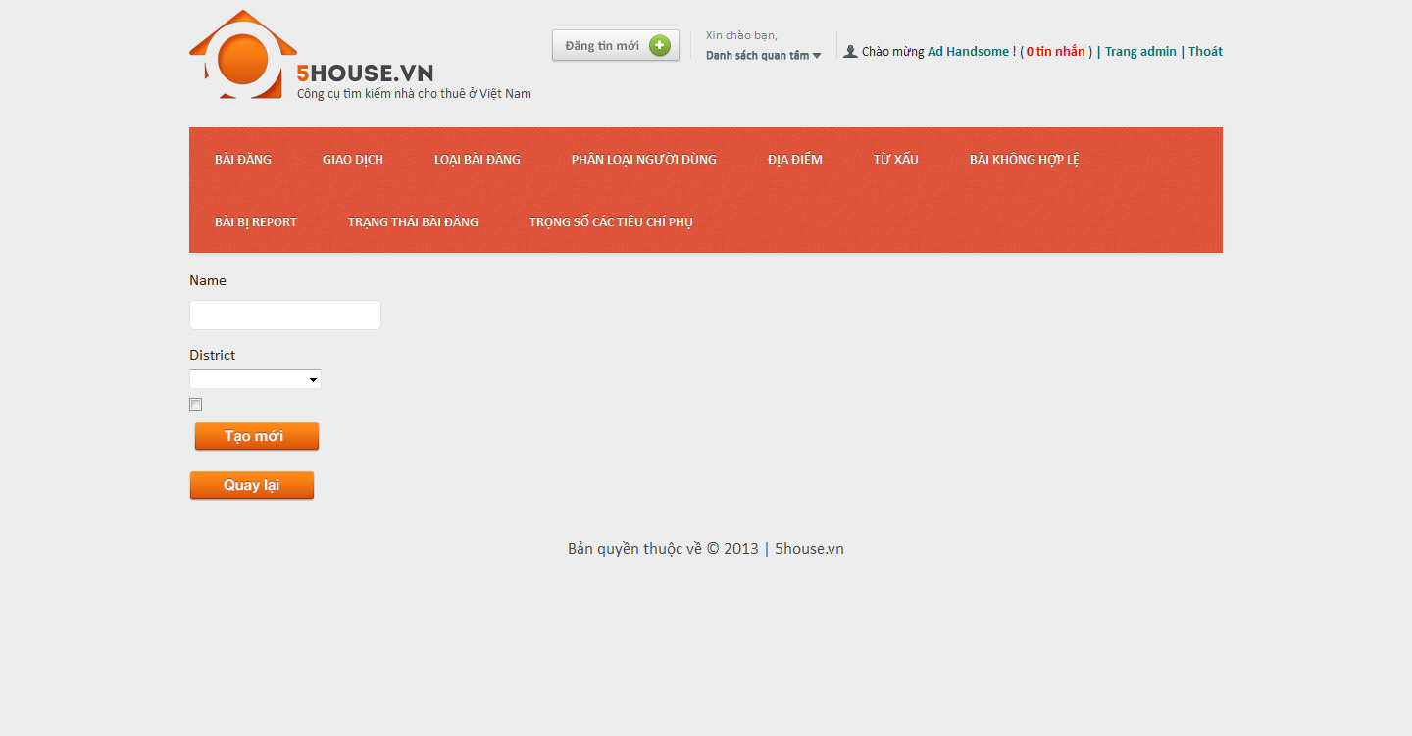

## Edit location

* + - * Login to the system as admin
      * Go to Admin Management page
      * Point on “Địa điểm”
      * Click on “Địa điểm phụ” tab
      * Click on an item on the table
      * Modify details
      * Click on “Lưu thay đổi” button
      * 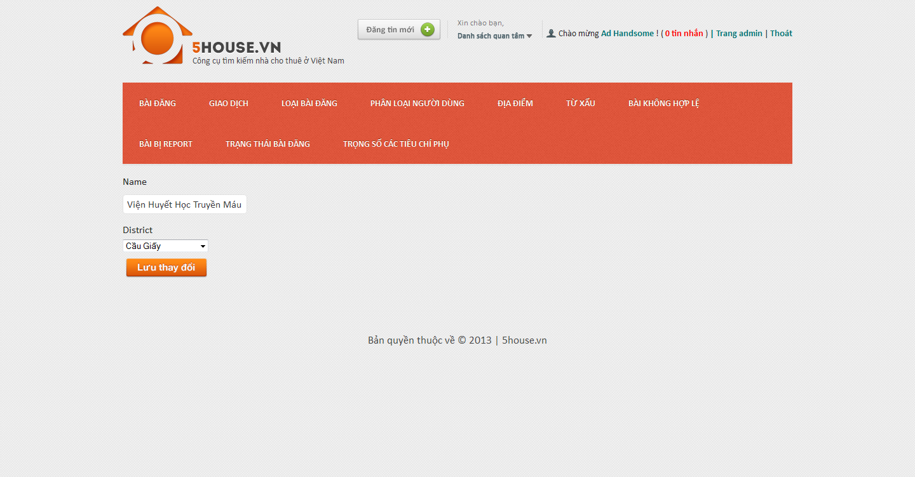

## Manage bad words

## View bad words list

* + - * Login to the system as admin
      * Go to Admin Management page
      * Point on “Từ xấu”
      * Click on “Từ xấu” tab
      * 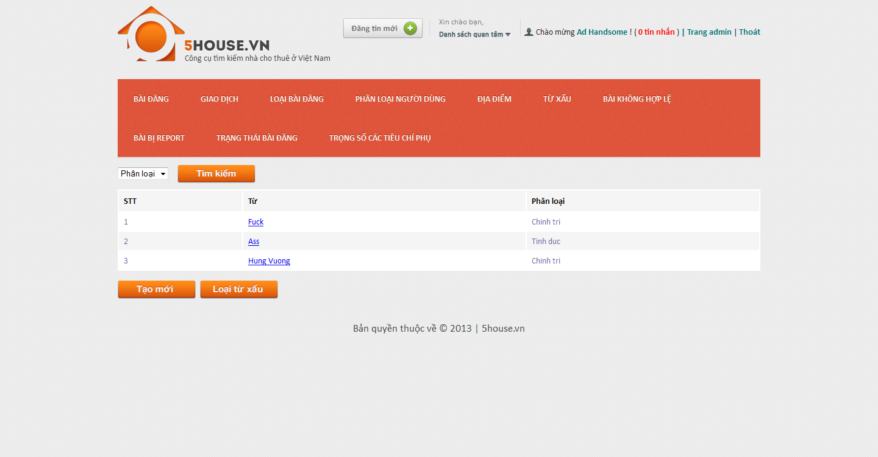

## Add new bad word

* + - * Login to the system as admin
      * Go to Admin Management page
      * Point on “Từ xấu”
      * Click on “Từ xấu” tab
      * Click “Tạo mới” button
      * Enter details as promted
      * Click “Tạo mới” button

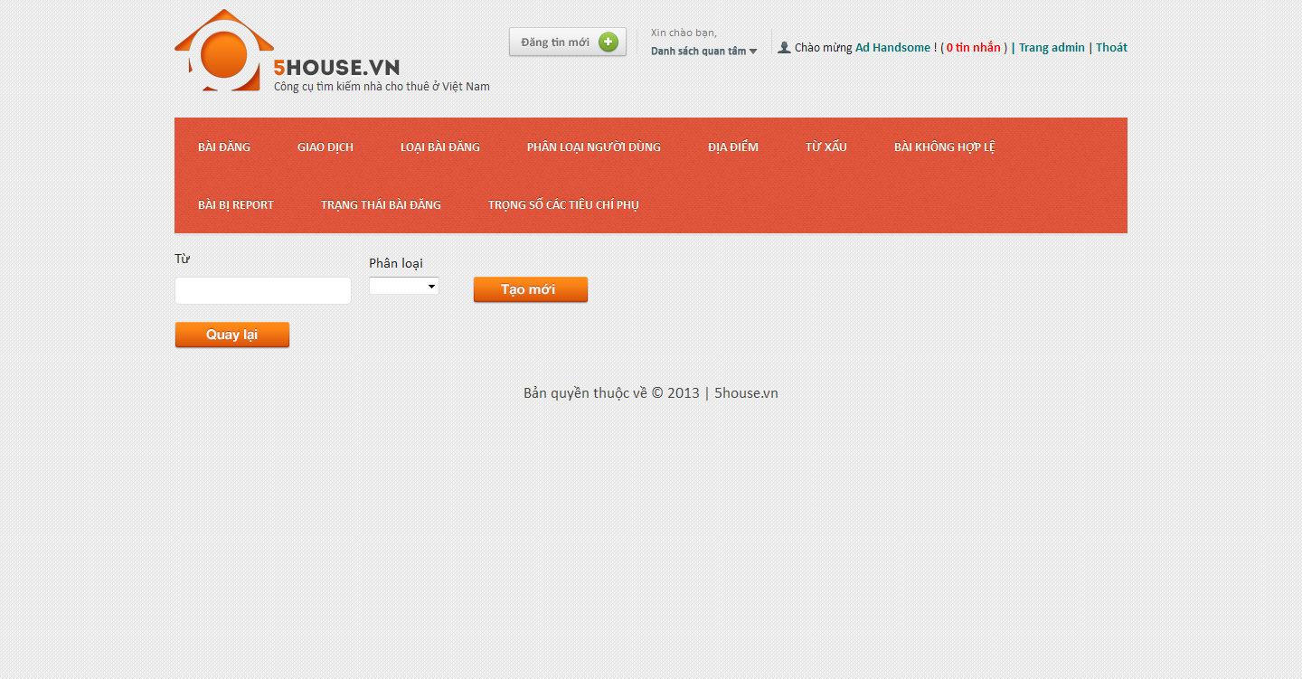

## Edit bad word

* + - * Login to the system as admin
      * Go to Admin Management page
      * Point on “Từ xấu”
      * Click on “Từ xấu” tab
      * Click on an item on the table
      * Modify details
      * Click on “Lưu thay đổi” button

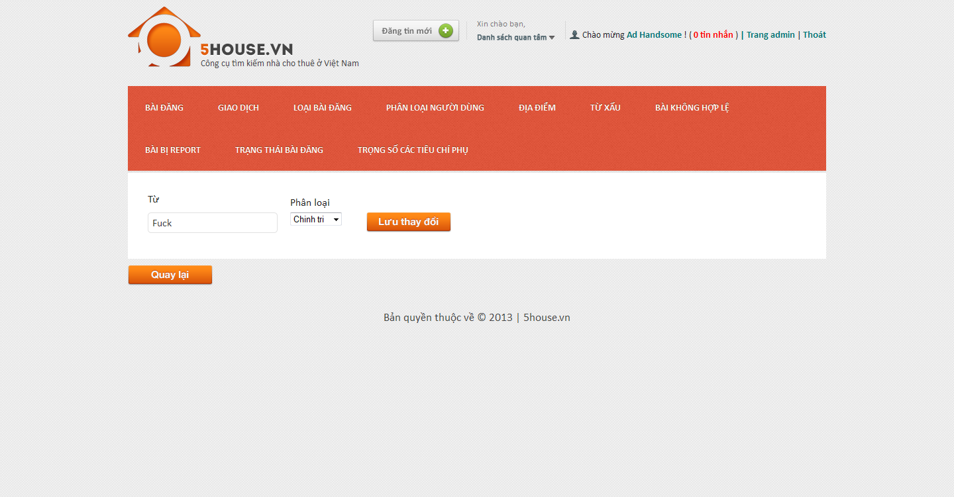

## Manage bad word categories

## View bad word categories list

* + - * Login to the system as admin
      * Go to Admin Management page
      * Point on “Từ xấu”
      * Click on “Phân loại từ xấu” tab

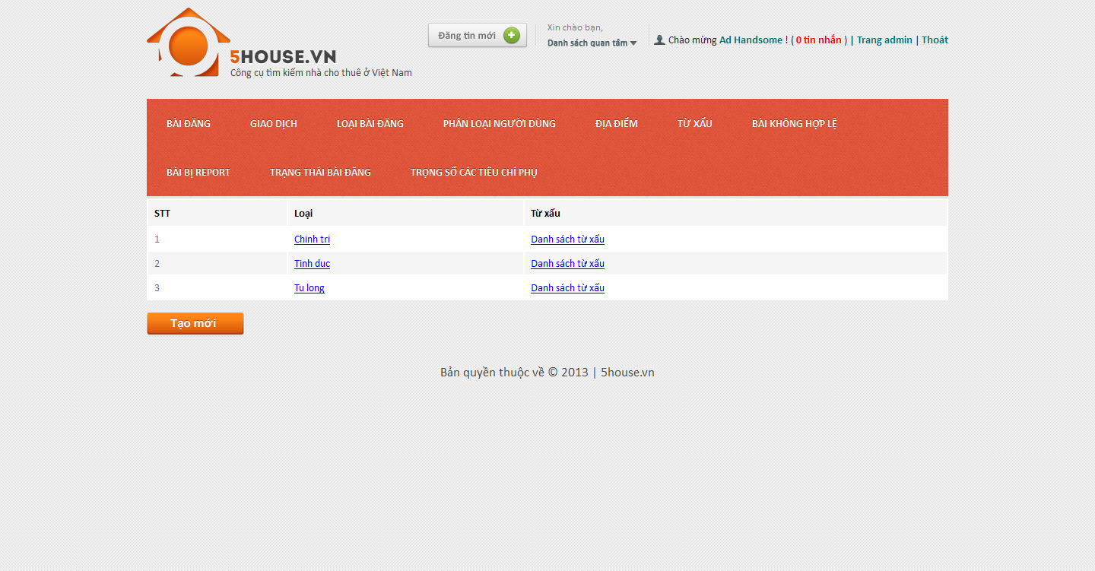

## Add new bad word category

* + - * Login to the system as admin
      * Go to Admin Management page
      * Point on “Từ xấu”
      * Click on “Phân loại từ xấu” tab
      * Click “Tạo mới” button
      * Enter details as promted
      * Click “Tạo mới” button

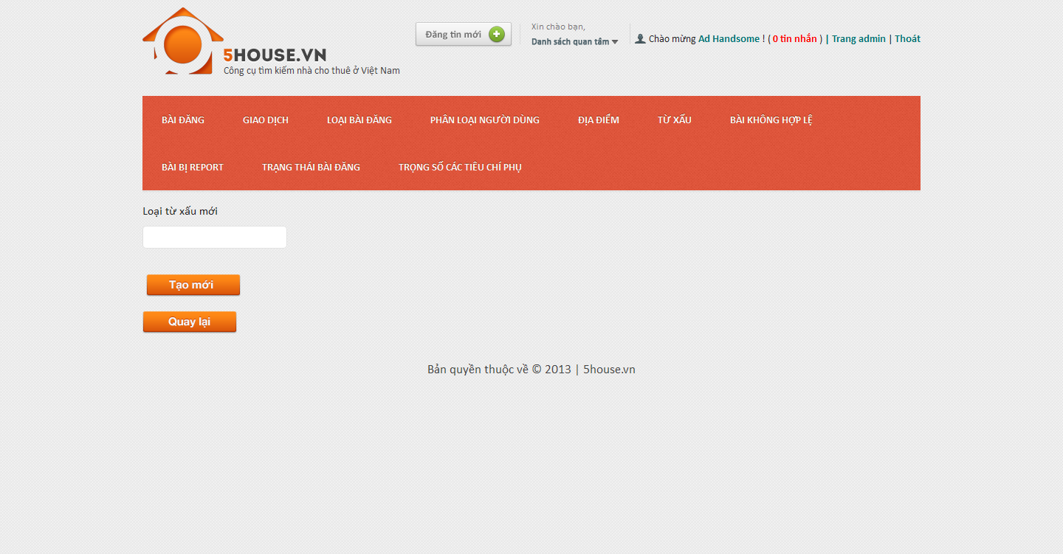

## Edit bad word category

* + - * Login to the system as admin
      * Go to Admin Management page
      * Point on “Từ xấu”
      * Click on “Phân loại từ xấu” tab
      * Click on an item on the table
      * Modify details
      * Click on “Lưu thay đổi” button

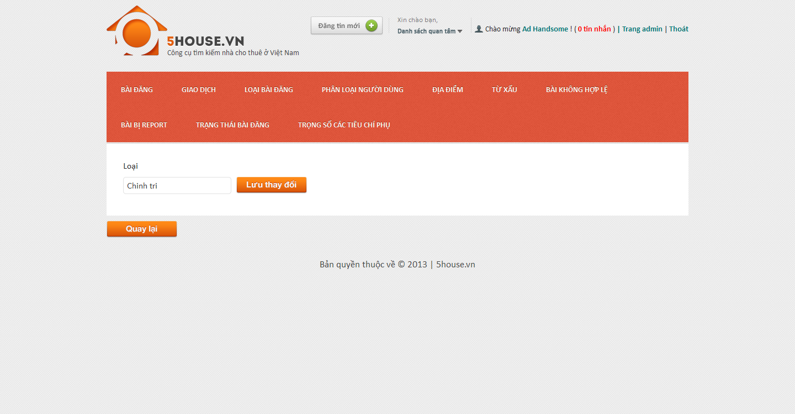

## Manage bad posts

* + - * Login to the system as admin
      * Go to Admin Management page
      * Click on “Bài không hợp lệ” tab
    - 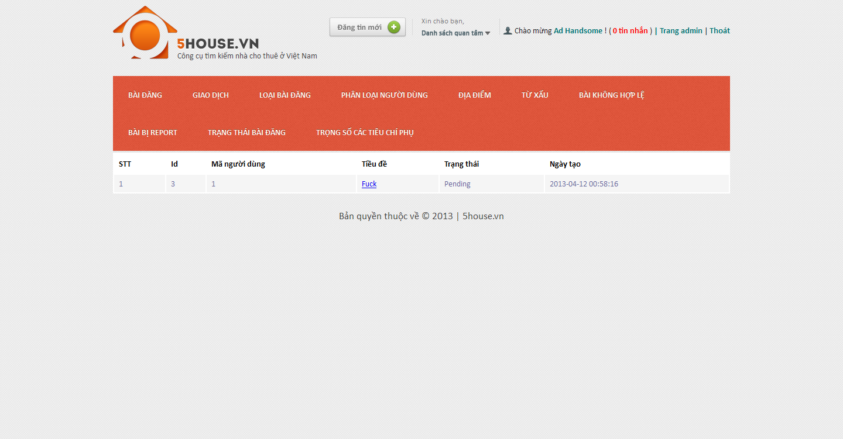

## Manage reported posts

* + - * Login to the system as admin
      * Go to Admin Management page
      * Click on “Bài bị report” tab
    - 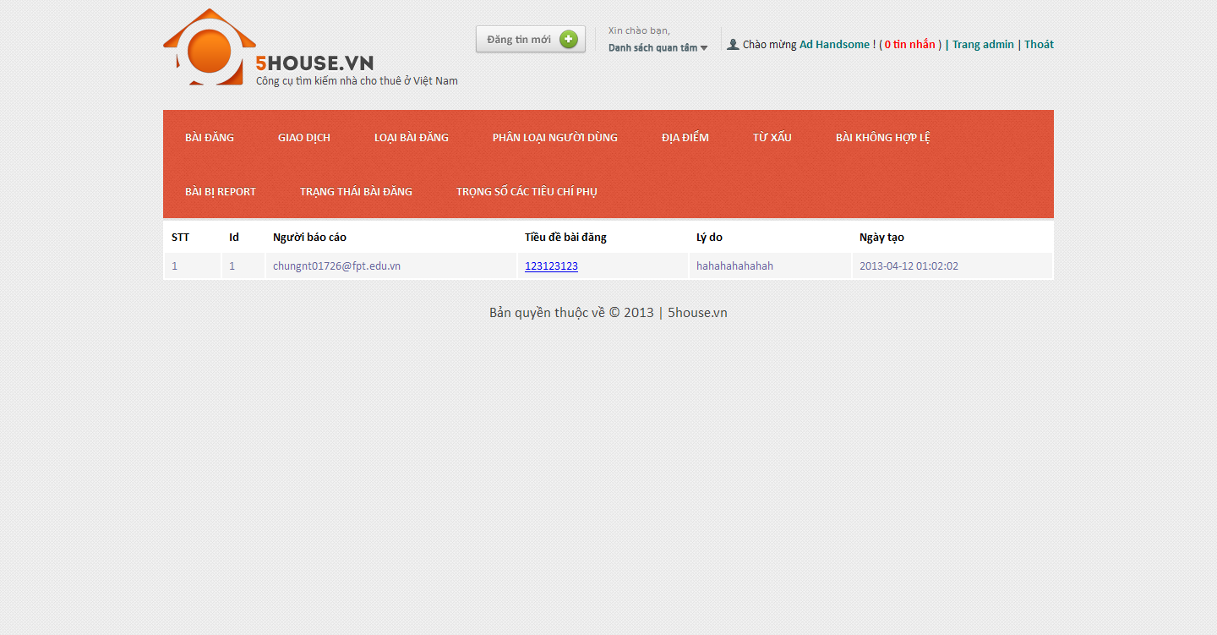

## Manage post statuses

## View post statuses list

* + - * Login to the system as admin
      * Go to Admin Management page
      * Click on “Trạng thái bài đăng” tab
      * 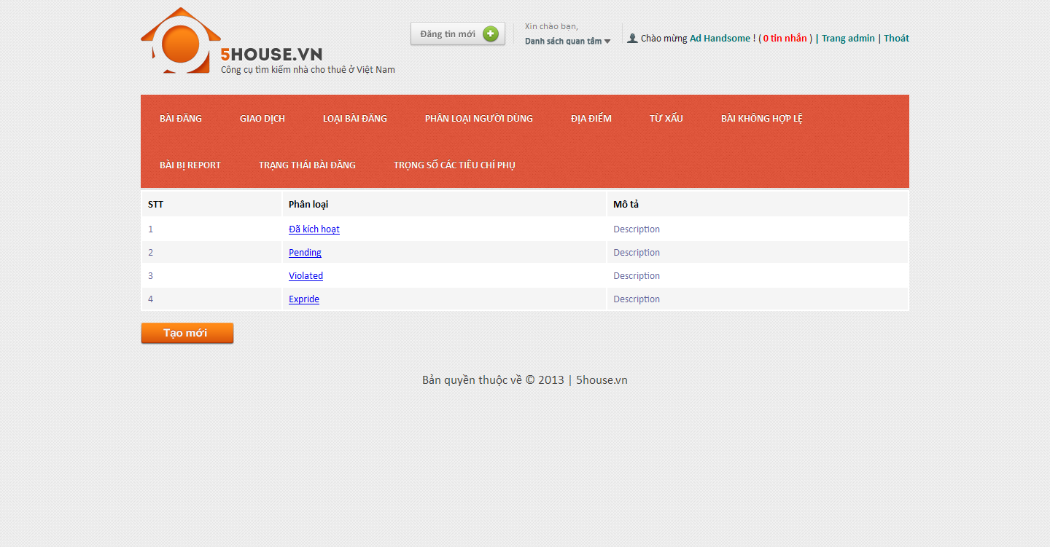

## Add new post status

* + - * Login to the system as admin
      * Go to Admin Management page
      * Click on “Trạng thái bài đăng” tab
      * Click “Tạo mới” button
      * Enter details as promted
      * Click “Tạo mới” button
      * 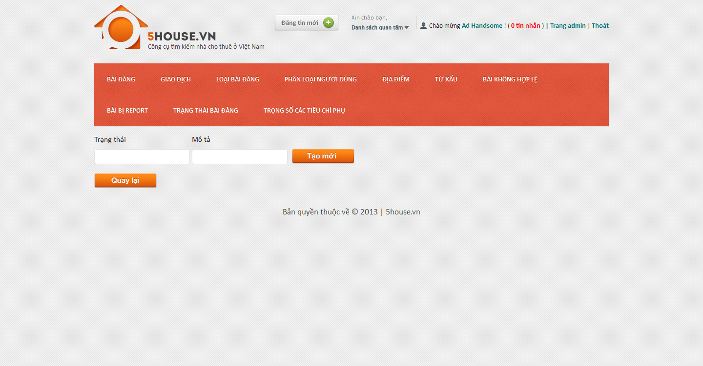

## Edit post status

* + - * Login to the system as admin
      * Go to Admin Management page
      * Click on “Trạng thái bài đăng” tab
      * Click on an item on the table
      * Modify details
      * Click on “Lưu thay đổi” button
      * 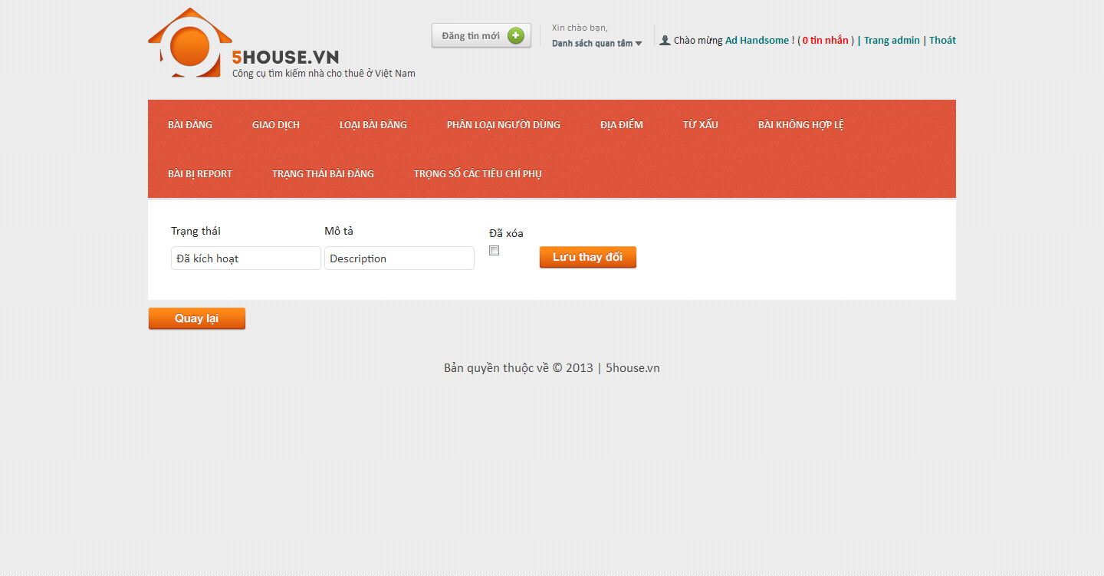

## Manage config score

## View score list

* + - * Login to the system as admin
      * Go to Admin Management page
      * Click on “Trọng số các tiêu chí phụ” tab

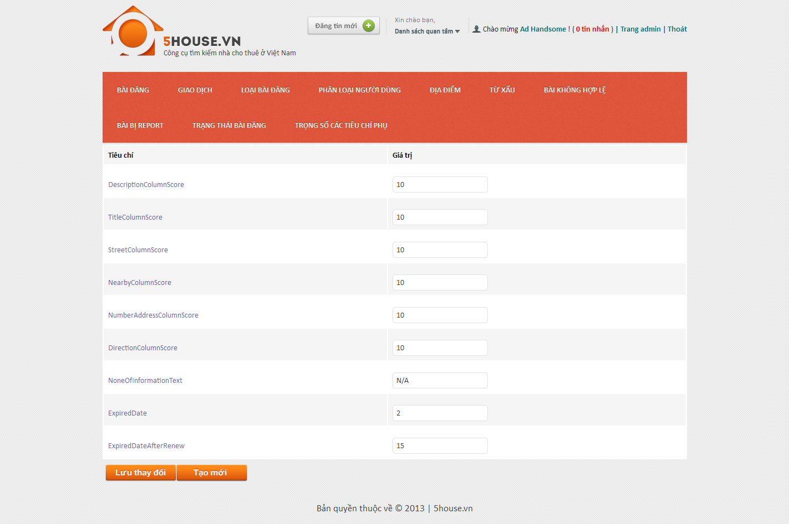

## Edit score value

* + - * Login to the system as admin
      * Go to Admin Management page
      * Click on “Trọng số các tiêu chí phụ” tab
      * Modify values
      * Click on “Lưu thay đổi” button



## Add new score

* + - * Login to the system as admin
      * Go to Admin Management page
      * Click on “Trọng số các tiêu chí phụ” tab
      * Click “Tạo mới” button
      * Enter details as promted
      * Click “Tạo mới” button

